# e-Skolar: A Web-Based Scholar Monitoring System for the University of Science and Technology of Southern Philippines (USTP)

**- A Case Study of the Admission and Scholarships Office**



Cagayan de Oro

Bucana, Paul Christian E. De Asis, Christian C. Ocat, Artemio R. Jr.

Sabuero, Charles C.

Department of Information Technology College of Information Technology and Computing

University of Science and Technology of Southern Philippines Lapasan, Cagayan de Oro City

January 2023

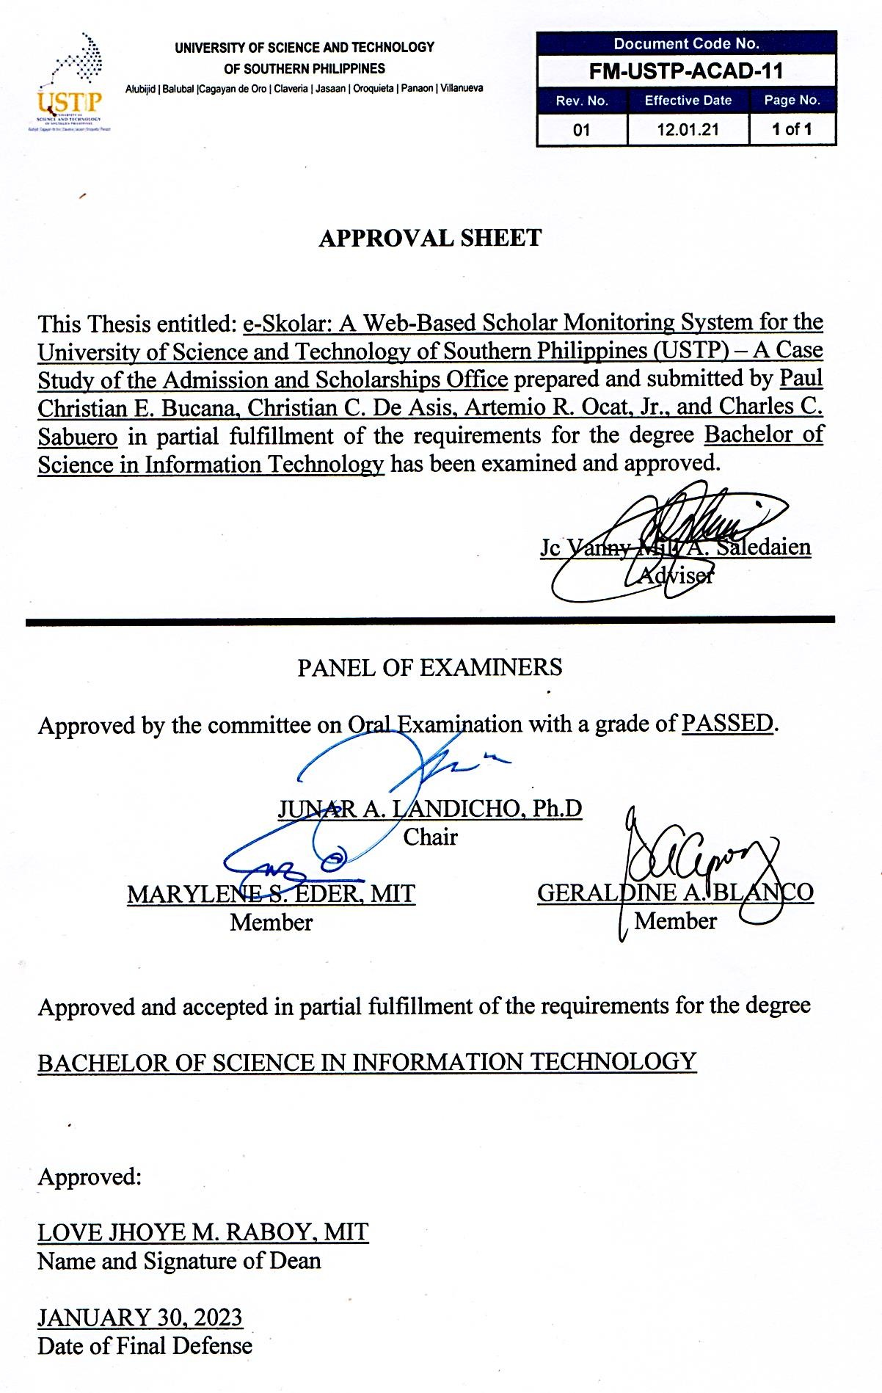

# ABSTRACT

The study focused on addressing the issues of the USTP Admission and Scholarship office of University of Science and Technology of Southern Philippines – Cagayan de Oro City campus in terms of monitoring and tracking scholars, time-consuming report generation, and communication challenges. To solve this, a web-based monitoring tool was needed. Hence, the e-Skolar - A Web- Based Scholar Monitoring System was proposed and developed. E-Skolar is a system that deals with the process of monitoring scholars by providing a document- tracking feature that will efficiently manage scholarship requirements. The system also helps ASO generate reports faster, as well as communicate with its fellow scholars better using a Short Message Service (SMS). The proposed system was tested using the Functionality Test, Usability Test, and System Usability Scale (SUS). The results of the surveys indicated major satisfaction among the respondents as they are satisfied of its consistency, well-integrated, and simple to use design for its users. It is functional, and usable as it greatly benefits the needs of scholars in monitoring their scholarship, as well as better work efficiency for ASO and its organizations to provide reports whenever needed.

*Keywords: scholarship, monitoring, report generation, document-tracking, short message service*

# DEDICATION

*This research is dedicated from the bottom of our hearts to our parents, who have been a source of inspiration and provided us with the strength and courage to persevere when we wanted to give up. They continue to provide us with moral, spiritual, emotional, and financial support. Lastly, we would like to thank the Almighty God for providing us with guidance, strength,, protection, skills, and a good health. We offer each of these to You.*

# ACKNOWLEDGEMENT

The researchers would like to acknowledge the adviser, Ms. Jc Vanny Mill Saledaien, and extend their deepest gratitude to her for the devotion and enthusiasm with which she helped make the research possible. Throughout the entirety of the process of producing the research paper, her direction was quite valuable. In addition, the researchers would like to express their gratitude to the panelists, Dr. Junar Landicho, Ms. Geraldine Blanco, and Prof. Marylene Saldon-Eder, for their guidance, insights, and expertise. Without them, the research would not have been able to make as much progress, and they would not have had the opportunity to experience project development in the field.

The researchers would also like to express their gratitude to their client, the Admission and Scholarship Office (ASO) of the University of Science and Technology of the Southern Philippines (USTP), which is led by their Director, Dr. Josephine Visande, who has been the most supportive of them. Without their involvement, the study wouldn't be a success.

Also, the researchers would like to thank their parents for their unwavering support and patience. The researchers express their deepest appreciation to the Almighty God, who provided them with insight, strength, and courage even during the most challenging phases of performing the research study.

TABLE OF CONTENTS

TITLE PAGE………………………………………………………………………i

APPROVAL SHEET………………………………………………………………ii

ABSTRACT……………………………………………………………………….iii

DEDICATION…………………………………………………………………….iv

ACKNOWLEDGEMENT…………………………………………………………v

TABLE OF CONTENTS

CHAPTER I INTRODUCTION 1

1.1 Background of the Study 1

1.2 Statement of the Problem 3

1.3 Objectives of the Project 4

1.4 Significance of the Study 5

1.5 Scope and Limitations 6

CHAPTER II REVIEW OF RELATED LITERATURE 8

2.1 Scholarship Monitoring 8

2.2 Document Tracking 10

2.3 Generating Reports 11

2.4 Short Message Services 14

2.5 Synthesis 15

CHAPTER III METHODOLOGY 16

3.1 Requirement Analysis and Design 16

3.1.1 Information Gathering 16

3.1.2 System Architecture 17

3.1.3 Use Case Diagram 18

3.1.4 Context Diagram 20

3.1.5 Level 1 Data Flow Diagram 21

3.1.6 Database Design 23

3.2 System Development 24

3.2.1 Hardware Requirements 24

3.2.2 Software Requirements 25

3.3 Testing 26

CHAPTER IV RESULTS AND DISCUSSION 29

4.1 System Screenshots 29

4.1.1. Homepage 29

4.1.3 Sample Reports 32

4.1.4 Announcements with SMS Feature 34

4.2 Results of the Testing 38

4.2.1 Functionality Test Result 38

4.2.2 Usability Test Result 39

4.2.3. System Usability Scale Result 40

4.3 Testing Discussion 41

CHAPTER V CONCLUSION AND RECOMMENDATIONS 42

5.1 Conclusion 42

5.2 Recommendations 43

REFERENCES 44

APPENDIX A: User Manual…………………………………………………….47

APPENDIX B: Code Snippets…………………………………………………...56

APPENDIX C: Communication Letter…………………………………………..60

APPENDIX D: Survey Forms……………………………………………………61

APPENDIX E: Documentations………………………………………………….63

APPENDIX F: Curriculum Vitae………………………………………………...66

APPENDIX G: Admission and Scholarships Office Organizational Chart …..…70

APPEDNIX H: Scholarship Manual……………………………………………...71

APPENDIX I: Functional Suitability and Usability Test………………………...72

APPENDIX J: System Usability Scale…………………………………………..73

APPENDIX K: Certificate of Acceptance……………………………………….74

**CHAPTER I**

**INTRODUCTION**

**1.1 Background of the Study**

The increasing number of students of the USTP has given them the opportunity to apply for any scholarships that they wished for. With this, many students monitor their statuses manually using Excel spreadsheet. The USTP Admissions and Scholarships Office (ASO) is the main in charge of enrolling and monitoring scholarships to university applicants. The volume of data handled by the office is a challenge when it comes to handling scholarship applicants and monitoring of scholars at the university. Additionally, university scholars need to comply with whatever requirements are given to them.

For many years, the USTP ASO handles scholarship monitoring in three ways: (1) at the student's discretion by showing up at the office to check on their status, (2) at the discretion of the ASO in reaching out to the respective USTP scholars through email, and (3) at the student’s initiative in submitting the necessary scholarship requirements either through email or at the office. Determining status of scholars is done manually using Excel spreadsheets. Because the scholar’s data must first be received from the USTP Registrar's Office before being entered into ASO's Microsoft Excel database, these processes can be inconvenient for the office. Furthermore, using Microsoft Excel to manage large amounts of data is not advisable. Microsoft Excel lacks control and security, is difficult to test or troubleshoot, is inefficient for collaborative work, and is prone to human error.

The USTP ASO currently delegates most of the monitoring responsibilities to its scholarship unit, with the cooperation of the umbrella scholar organization, the USTP Scholars Society, as well as its fellow unit scholar organizations and representatives. Unfortunately, the ASO does not have an online system to help them monitor scholars under different scholarship programs.

A monitoring system is a software that helps offices and businesses monitor their assets and users. Without an online system, the office must rely largely on the different scholar organizations and representatives to manually provide updates, reports, and data on scholars, which is inconvenient. The study aims to design and develop a system that assists the ASO and other scholar organizations in keeping track of scholars. Scholars can monitor their progress and learn about the eligibility requirements for maintaining their scholarship. ASO would benefit from the system as well, in terms of report generation of scholar’s status in the respective scholarships offered by the office.

**1.2 Statement of the Problem**

Given the large number of scholars at the university, the system aims to address issues concerning difficulty in tracking scholar status in terms of documentary requirements completion and other responsibilities that the office is required to monitor. The ASO staff typically consolidates scholarship data using spreadsheet software, which makes report generation time-consuming as it requires the data encoder to input scholarship-related fields manually. In terms of communication, the ASO and other scholar-led organizations also find it challenging to communicate with scholars because all announcements are usually posted on social media and not all scholars are always online.

**1.3 Objectives of the Project**

The study aims to design, develop, and test the Scholar Monitoring System for the Scholarship Unit of the University of Science and Technology of Southern Philippines System. Specifically, it aims to (1) design a system that supports the Admission and Scholarship Office in monitoring existing scholars in terms of their scholarship requirements by providing a scholarship document-tracker feature that can efficiently track missing, pending, and completed requirements of the scholars, (2) to develop a system that will help office staff generate scholarship status reports faster and (3) make communication between the ASO and the scholars easier through the use of SMS by delivering messages related to their scholarship. The researchers evaluate the system in terms of its functionality and usability using the System Usability Scale.

**1.4 Significance of the Study**

The system is a vital tool for the Admission and Scholarship Office, the scholars, the organization for scholars, and future researchers. This system provides an efficient and reliable platform that enables the monitoring of documentary requirements and deliverables of existing scholars in the university.

For the Admission and Scholarship Office, the system offers a centralized system for tracking the progress of scholars and monitoring compliance with scholarship requirements. By streamlining the monitoring process, the system enables the office to focus on providing quality support to scholars and improving the overall scholarship program.

For the scholars, the system offers a user-friendly interface that allows them to easily submit and track their documentary requirements and deliverables. The system provides timely reminders of submission deadlines, helping scholars stay on track with their scholarship requirements. The system also enables scholars to have more transparency in their scholarship status, allowing them to focus on their academic goals without worrying about their scholarship requirements.

For the organization for scholars, the system provides a platform for reaching out to their fellow scholars.

For future researchers, the system provides a valuable resource for studying scholarship management processes and identifying areas for improvement.

Overall, the system has the potential to improve the efficiency and effectiveness of the scholarship monitoring process, resulting in better outcomes for scholars, the Admission and Scholarship Office, and the organization for scholars.

**1.5 Scope and Limitations**

The scope of the study primarily focuses on monitoring current USTP scholars. The system covers processes in the monitoring system involving registering existing scholars, tracking, and monitoring of scholars in the system. The system provides security modules that have three user levels: The ASO Scholarship In-Charge acts as the system administrator and oversees the creation and management of scholar accounts, as well as verifying scholars, creation, and management of scholar organization accounts, managing, and verifying requirements, generating reports, and sending out announcements. The Scholar Organization can use the system to post organization-related announcements and use the system to generate scholar reports. Lastly, the scholars can use the system to know their scholarship status, view requirements, and submit their documents in relation to the requirements.

As such, the project study has its limitations. The system can only be accessed via a web browser, so an internet connection is required. Verification of scholarship requirements and related documents can only be done by the scholarship unit of ASO, as the system does not have the capability to automatically detect whether the scholarship requirement submitted is valid. Due to budget constraints, the researchers heavily rely on free, and low-priced web application services for the system development and its features.

**CHAPTER II**

**REVIEW OF RELATED LITERATURE**

**2.1 Scholarship Monitoring**

The Study of the Student and Alumni Development Institute (LPMA) of the Universitas Muhammadiyah Magelang carries out its monitoring activities by collecting students' hard copy files. The results of these activities are then decided by a scholarship working group in the university on the number of activities the students are going to conduct for the next period. These activities are also a reference to provide an insight for better scholarship opportunities they wish to take in the university in the future. Unfortunately, the manual process of collecting hard copy files has led to unintentional data loss and duplication. To solve this, a monitoring information system was proposed to facilitate the working group and LPMA to efficiently monitor students whether they were able to contribute to the institution or not. Results of the implementation showed that 79% of the users were satisfied with the system for being able to assist students and manage monitoring scholarships in the university (Arumi et. al., 2019).

In 2016, An E-Scholarship System was devised at the Federal College of Education in Kontagora, Nigeria. Here, the system aimed to provide an online application solution that saves time and provided notifications using SMS emails and alerts on the scholarship application progress in an efficient manner. This was to solve the errors in terms of time-consuming applications, and help monitor the overall process of scholarships to students. The system was implemented in order to allow Niger state indigene students around the country to apply scholarships with the Niger State Scholarship Board through the internet.

Another related study is from Batangas State University, where researchers designed a system in regard to online scholarship application and record management. The focus of the system was to eliminate paper-based or manual based methods of processing by AYZ City Scholarship Office (Marave, 2019). The system was able to provide the conveniency and effective way in giving a reliable service in the scholarship program AYZ CSO offered. It improved the productivity of the scholarship office’s workforce in storing records, and increased efficiency in terms of recording and monitoring information of scholars.

**2.2 Document Tracking**

PRISMS is the main management system for USTP students to access their grades, Certificate of Registration, and schedules of their subjects. In addition, student enrollment takes place on this website. The dashboard contains subject enrolled, grades, evaluation, QR code, and scholarship module. Inside the scholarship module, the student may apply for any of the available scholarships, or for those scholars, see their “approved status”.

Unfortunately, the scholarship module in PRISMS is only limited to the application of scholarships, and the applicant’s status. Therefore, the process of monitoring and tracking scholars does not exist in this system.

In Iraq, electronic documentation management system was developed for the Directorate of Scholarship and Cultural Relations. It was made to effectively reduce the effort of doing the work and save time in tracking and processing documents from students (Kadhim and Mohammed, 2014). The document tracker had the ability to convert files into digital form, apply information to digital files, and save images in the database. The result of the system implementation was a decrease in transaction time, reduce the space of document storage safely, and lessen the chances of data corruption. The system was able to give more power and control for the directorate’s staff and managers to track their workforce in conducting their job responsibilities.

At the Donald and Barbara Zucker School of Medicine at Hofstra/Northwell, researchers developed a digital repository to gather and showcase scholarly outputs of the Northwell Health Medical School system. Entitled Zucker School of Medicine Academic Works, this repository system promotes scholarship by people through a centralized public website (Rand and Stager, 2018). With reference links to these documents, the system allows discoverability and access while retaining scholarship value in the institution. In addition, the information management system further harvest publications which enhance the aim of reporting, tracking, and promoting scholarly activities.

**2.3 Generating Reports**

In India, the government has implemented the “National Scholarship Portal” which is a one-stop solution for Indian scholarships through various services, which include student application receipt, processing, sanction, and disbursal of various scholarships to students. The benefit here is a simplified process for the students: all scholarship information is available on the portal and is integrated for all scholarships. (Ministry of Electronics and Information Technology, 2018)

Aside from its integrated scholar application feature for students, one great feature is its transparent scholar database. Having a master database is necessary to ensure applications are processed correctly, avoid unintentional data duplication, and generate necessary reports easily. Having this feature helps the scholarship office track and monitor scholars efficiently and transparently.

A similar study was conducted by Eric Irvin Sauser in 2011 at the University of Northern Iowa College of Administration. It focused on developing a system designed to assist scholarship awarding process and viewing data regarding applicants and scholarships. It aimed to address the issues in tracking scholarship information as many information files were not centralized. With the system implemented, it was able to provide easy-to-use, customizable reports, provide the most update-to-date data that can be accessed anywhere, and an efficient process in the scholarship awarding.

In 2021, the Scholarship Information with Decision Support System was developed in Isabela State University by Prince Ariel R. Alvaro and Von P. Gabayan Jr. It aimed to manage scholarship records, support scholarship-granting and reporting, and provide a decision-support feature that can help scholars know the risk level of non-graduation. The result was a 98.6 percent accuracy of the decision support feature with the usage of Waikato Environment for Knowledge Analysis (WEKA), an open-source data mining tool. As such, report generation for scholarships may be expanded not only for recording and generating scholarship data, but also for data mining which can help scholars determine their chances of graduation based on the academic performance they have submitted in the system. CSM Technologies currently offers a web application that provides scholarship management for schools, institutions, and scholarship programs. The web application contains three modules: the Scholarship Application Management module, the Disbursement Module, and the Management Information System (MIS) Module. The Scholarship Application Management handles student applicants. The disbursement module handles the payment and sending of financial grants, aids, and allowances. The MIS Module handles report generation of scholars’ data to stakeholders. The system may also be integrated with other CSM’s offered systems, such as the School Administration System and the Admission Management System.

Report generations are essential for the scholarship office to provide the necessary information about scholars to respective offices and partners, whenever needed. As such, when scholars are being monitored for their status, reports can be easily created through the monitoring system without going through the manual process of checking in spreadsheet software.

**2.4 Short Message Services**

The CDO City Scholarship Website is a portal for the beneficiaries of the Iskolar sa Dakbayan (IsDA) in the city of Cagayan de Oro. Scholarship accounts for individuals are registered by the office for scholars to access the exclusive features of the portal. To login, the user must provide your first name, last name, and birthdate. After submitting, a one-day limited access code will be sent in the user’s mobile number that should be used to login into the portal. Its features include the featured news section, online scholarship application, and for registered scholars, grade submission and download of scholarship certificates. (CDO City Scholarships Office, 2018). Web portals are important as they can be used to offer services and resources (Katz, 2002). As such, having a scholarship portal helps city scholars be able to access its features, submit and download necessary requirements. These can be tracked by the office to help staff monitor the status of USTP scholars.

**2.5 Synthesis**

A scholar is monitored by various authorized offices and/or organizations. As the university's current situation allows administrators or staff to manage scholars online, this system will support various offices and organizations in providing essential services to the institution and its scholars. The related systems and studies stated above were necessary to support the idea of providing the university with a scholarship monitoring system that will cater to USTP scholars, organizations, and the Admission and Scholarship Office. The table below compares various existing systems to this system in terms of their common features relating to monitoring scholars.

**CHAPTER III**

**METHODOLOGY**

**3.1 Requirement Analysis and Design**

**3.1.1 Information Gathering**

This study was conducted at the University of Science and Technology of Southern Philippines located in Lapasan, Cagayan de Oro City, Philippines. The main respondents in the conduct of this study were the scholarship staff of the Admission and Scholarship Office, the student-led scholars' organization representatives, and 4th year IT scholars. To further understand the processes involved in monitoring scholars, the researchers conducted a series of one-on-one in-person interviews with ASO staff (Appendix A). Aside from providing important insights, ASO staff also provided the researchers with their organizational chart (Appendix D) and scholarship manual (Appendix E) so that they could go deeper into the area of the study that focuses on monitoring scholars. In addition, the researchers conducted one-on-one interviews with the organizations involved (Appendix B). Finally, as part of the researchers' initial data collection, a survey questionnaire (Appendix C) was distributed to the scholars via Google Forms. The researchers were also given a copy of the office’s organizational chart to understand its hierarchy.

**3.1.2 System Architecture**

In the System Architecture the scholars, organization and ASO can manage data to the Web application and the Web application will display the reported data. The researchers used HTML, Tailwind CSS, and JavaScript at the frontend. The researchers used PHP, JavaScript and Laravel with Filament at the backend and for the cloud server the researchers used HTML, CSS for the file system, MySQL and MariaDB. is used for databases. Data flow starts from the three mentioned users to manage and submit data in the system architecture. Any of the inputs made by the users are viewed and received by other respective users. Any changes of data are also going to be reflected in the respective visual interfaces.

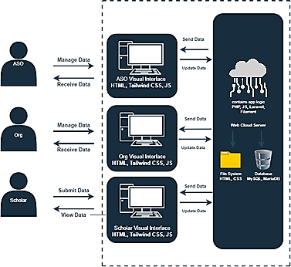

Organization

*Figure 1. System Architecture of the System*

**3.1.3 Use Case Diagram**

In the Use Case Diagram there are three users: the ASO, organization and the scholar. The ASO, which is the admin, can manage all the features in the system. The ASO also manages the users, roles, and permissions of the system. The organization can only login, view scholars, generate reports, and manage announcements. Meanwhile, the scholar can only login or logout, view and submit documents required and view announcements.

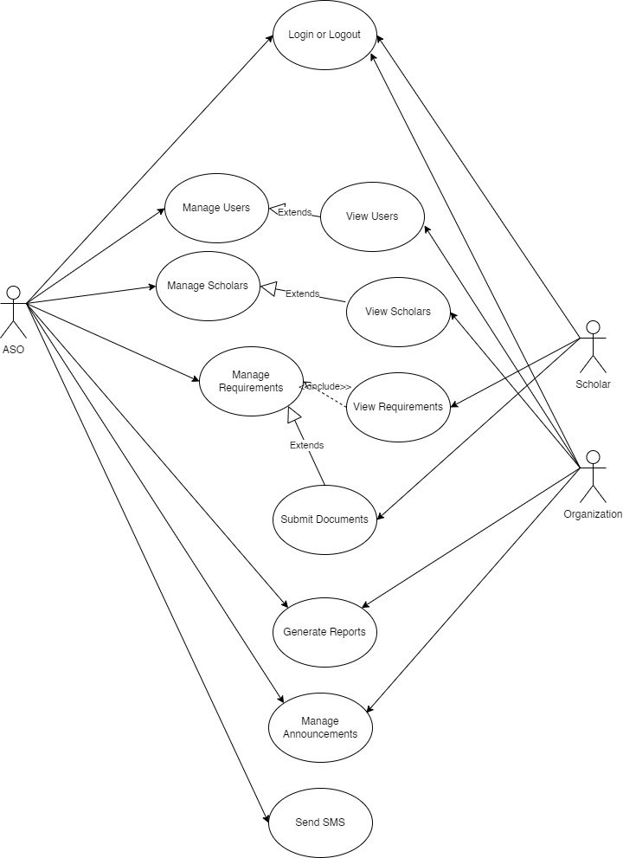

*Figure 2. Use Case Diagram of the System*

**3.1.4 Context Diagram**

In the context diagram, the ASO can login or logout manage users, manage scholars, manage requirements, manage announcements, and generate reports of scholars. The organization can login or logout, generate reports of scholars and manage announcements. The scholar can login or logout, submit documents required, view announcements and requirements from ASO and organization.

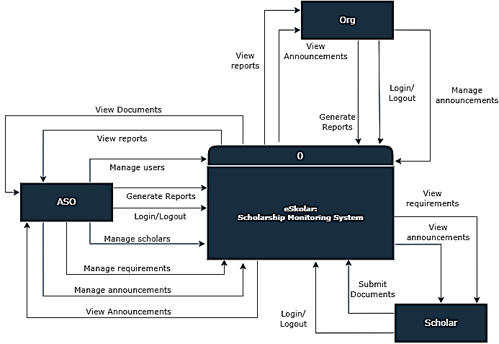

Organization

Login or Logout

*Figure 4. Context Diagram of the System*

**3.1.5 Level 1 Data Flow Diagram**

In the Data Flow Diagram, the user, scholar, requirement, report generation and announcement info is managed by the Admission and Scholarships Office. The scholar can see the requirement and announcement info, and submit necessary documents required by the office. The organization manages scholars, can generate reports, and provide announcements to scholars.

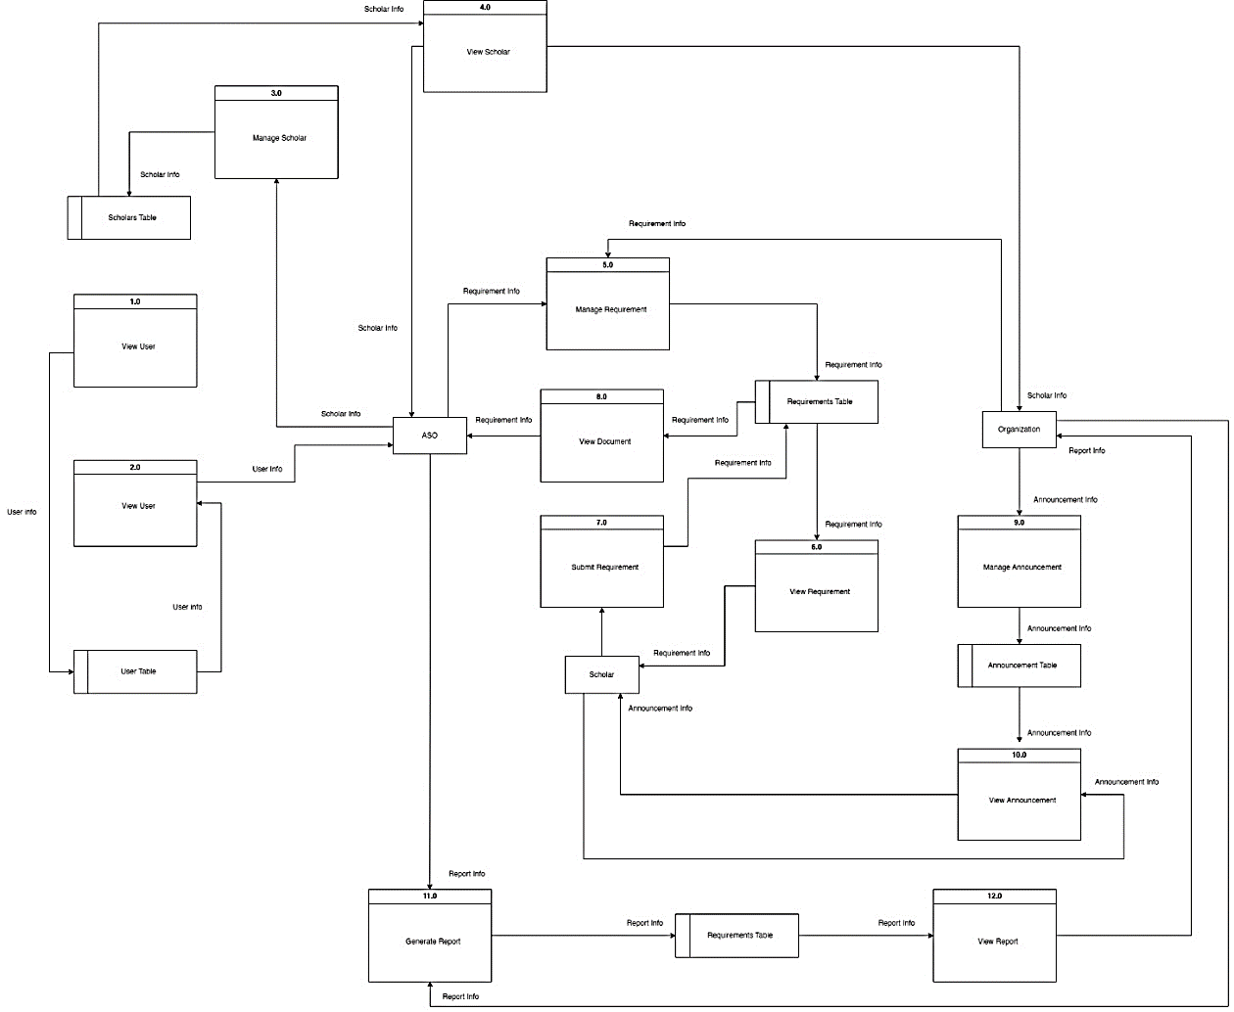

*Figure 5. Level 1 Data Flow Diagram of the eSkolar System*

**3.1.6 Database Design**

Organization and Students have a user account, together with the Admin and Staffs. They are separated by user type, and Student has program, and sponsor, and the status of the student can be accessed through the Monitoring Table. Announcements can be organized by admin, staff and organization, announcements cannot be made by students, and the status of the announcement can be lifted if the requirement is verified by the admin. The database design is important for the project’s development as it provides the essential guide of how data is managed in the system.

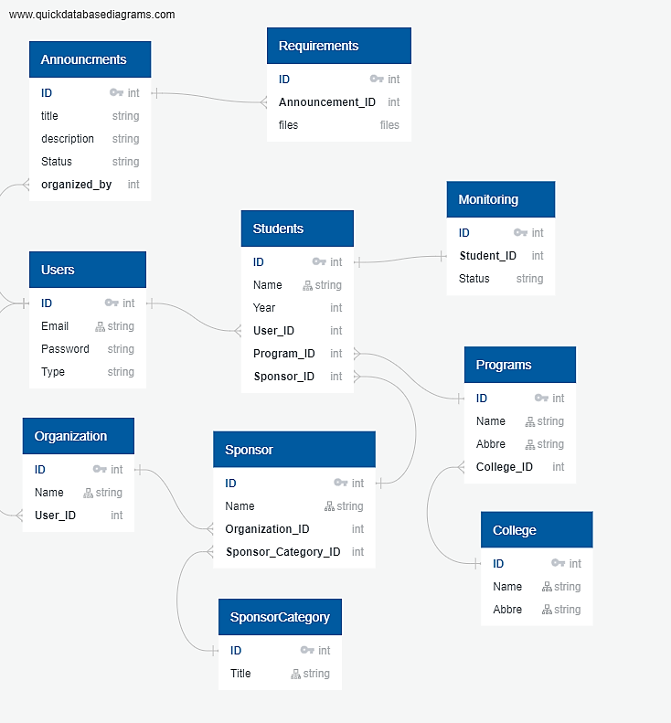

*Figure 6. Database Design of the System*

**3.2 System Development**

**3.2.1 Hardware Requirements**

The hardware requirements needed to develop, and use require the use of the internet. For all system users, the system management will be done through the cloud. For the system to run efficiently. Since the system is going to be implemented online only, the researchers recommend users to have a minimum specifications of a dual core processor, at 8GB of RAM, and internet access with an Ethernet connection or wireless adapter (Wi-Fi).

*Table 2. Hardware Requirements of the eSkolar System*

|  |  |
| --- | --- |
| Operating System | Windows 8.1 and above (64-bit version) |
| Processor | Dual-Core Processor |
| Memory | 8GB RAM |

**3.2.2 Software Requirements**

During the development, Laravel, Filament, and Tailwind were used to build the web application. The researchers used Laravel because of its robust scalability, and efficiency in the application development process (Hue, 2014). The security features, better stability and faster development speed has made Laravel a popular tool among many developers. Tailwind is a popular front-end CSS framework, which enables developers to quickly develop front-end applications without the need to write CSS codes manually. Filament is a collection of tools and templates to develop stack web applications. It is used alongside Tailwind and Laravel. In addition, Font Awesome was also used to insert necessary icons and vector images for the website. All of these development processes are made using Visual Studio Code, an IDE developed by Microsoft, which is a popular IDE tool for many developers due to its features such as in syntax highlighting, auto-indentation, snippets, and support for plugins. NPM, a package manager for web development, was used to deploy the necessary tools for development. For browsers, Chrome, Firefox, or Chromium browsers are supported. For the operating system, at least Windows 10 is recommended.

*Table 3. Software Requirements of the System*

|  |  |
| --- | --- |
| Front-end Framework | Tailwind, CSS, Alpine JS, HTML |
| Back-end Framework | Laravel |
| IDE | Microsoft Visual Studio Code |
| Database | MYSQL + MariaDB, XAMPP |
| Packages | Filament, NPM, Composer, Font Awesome |
| SMS API | Semaphore |

**3.3 Testing**

The respondents tested the system using a questionnaire on a 5-point Likert scale that measures the Functional Suitability and Usability patterned after ISO/IEC 25010 criteria in determining standard software development.

Functional Suitability measures the degree to which the system provides functions that meet stated and implied needs when used under specified conditions. It had the following sub-characteristics: Functional Completeness, Functional Correctness, and Functional Appropriateness.

Usability measures the degree to which a product or system can be used by specified users to achieve specific goals with effectiveness, efficiency, and satisfaction in a specified context of use. It has the following sub-characteristics: Appropriateness, Recognizability, Learnability, Operability, User error protection, User interface aesthetics, and Accessibility. Table 2 below shows the corresponding verbal interpretation of the Likert scores.

*Table 4. Likert Scale for System Evaluation*

|  |  |  |
| --- | --- | --- |
| Rating | Mean Range | Verbal Interpretation |
| 5 | 4.21-5.00 | Excellent |
| 4 | 3.31-4.20 | Very Good |
| 3 | 2.61-3.30 | Satisfactory |
| 2 | 1.81-2.60 | Fair |
| 1 | 1.00-1.80 | Poor |

The rating sheet (Appendix I) included instructions on how to answer the evaluation form. In addition, the researchers briefed the respondents about the purpose of the study prior to the evaluation. Below were the criteria that the respondents had to evaluate during the system evaluation.

In addition, the System Usability Scale (SUS) (Appendix J) was utilized to further evaluate the system. It is a reliable, and industry standard tool created by John Brooke in 1986. It allowed researchers and developers to evaluate a wide variety of services and applications, such as websites.

**CHAPTER IV**

**RESULTS AND DISCUSSION**

This chapter contains the survey findings and the discussions during the study process. The results of the study are presented and discussed with reference to the aim of the study, which was to help the Admission and Scholarship Office in monitoring the documentary requirements of the scholars.

**4.1 System Screenshots**

**4.1.1. Homepage**

Visitors to the website can view eSkolar's landing page. The landing page contains a few details regarding the university's existing scholarship programs.

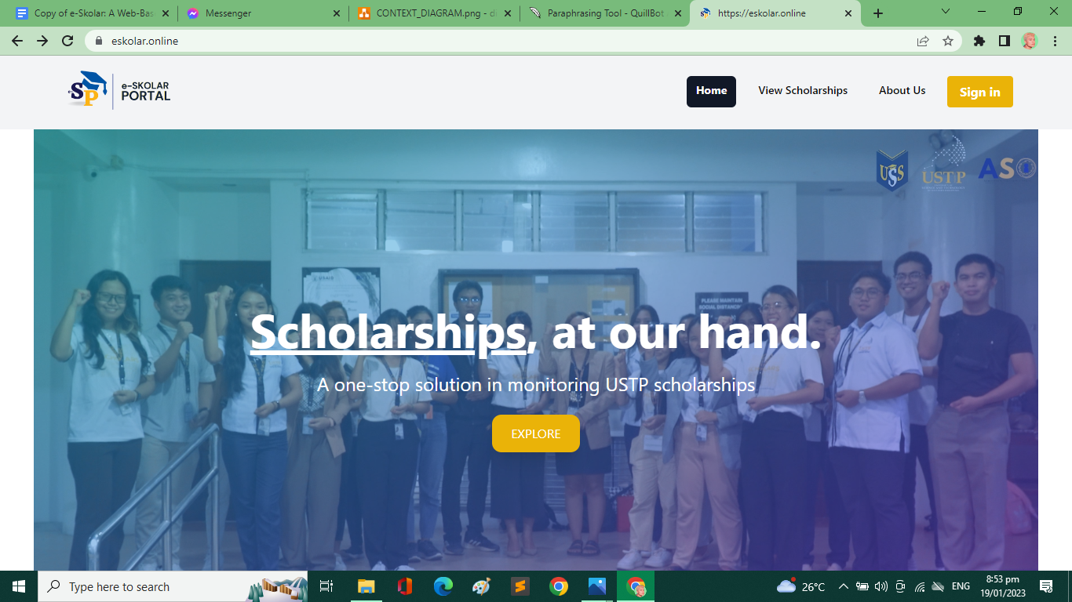

*Figure 7. Landing Page*

When visitors click the view scholarship navigation link, they can view the available ASO-affiliated scholarships.



*Figure 8. View Scholarships Tab of eSkolar System*

When the login button in the navigation bar is clicked, the login page is displayed. ASO personnel, organization officers, and scholars can use their credentials to log in to the portal.

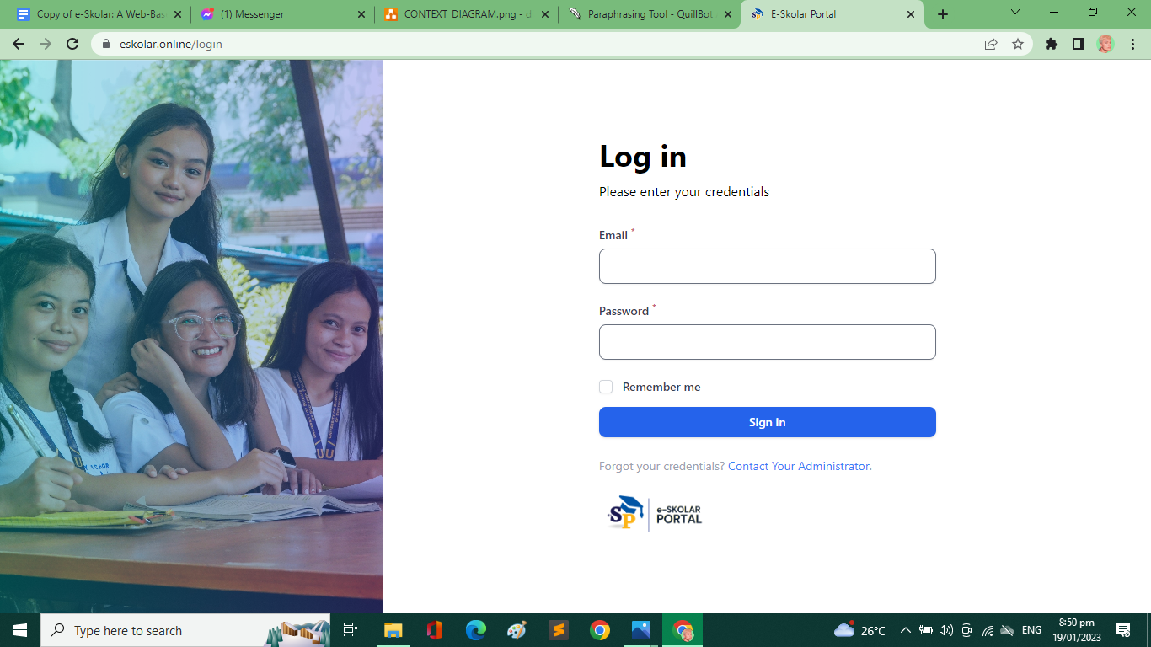

*Figure 9. Login Screen of eSkolar System*

**4.1.3 Sample Reports**

The ASO staff can choose the fields and columns to include in the report, and the system will generate the report accordingly.

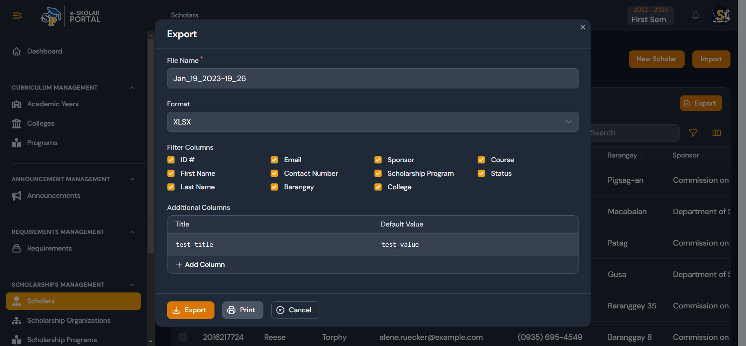

*Figure 10. Export Scholar Report List*

In addition, the ASO staff is able to print the exported scholar report in order to meet their requirements for document preparation.

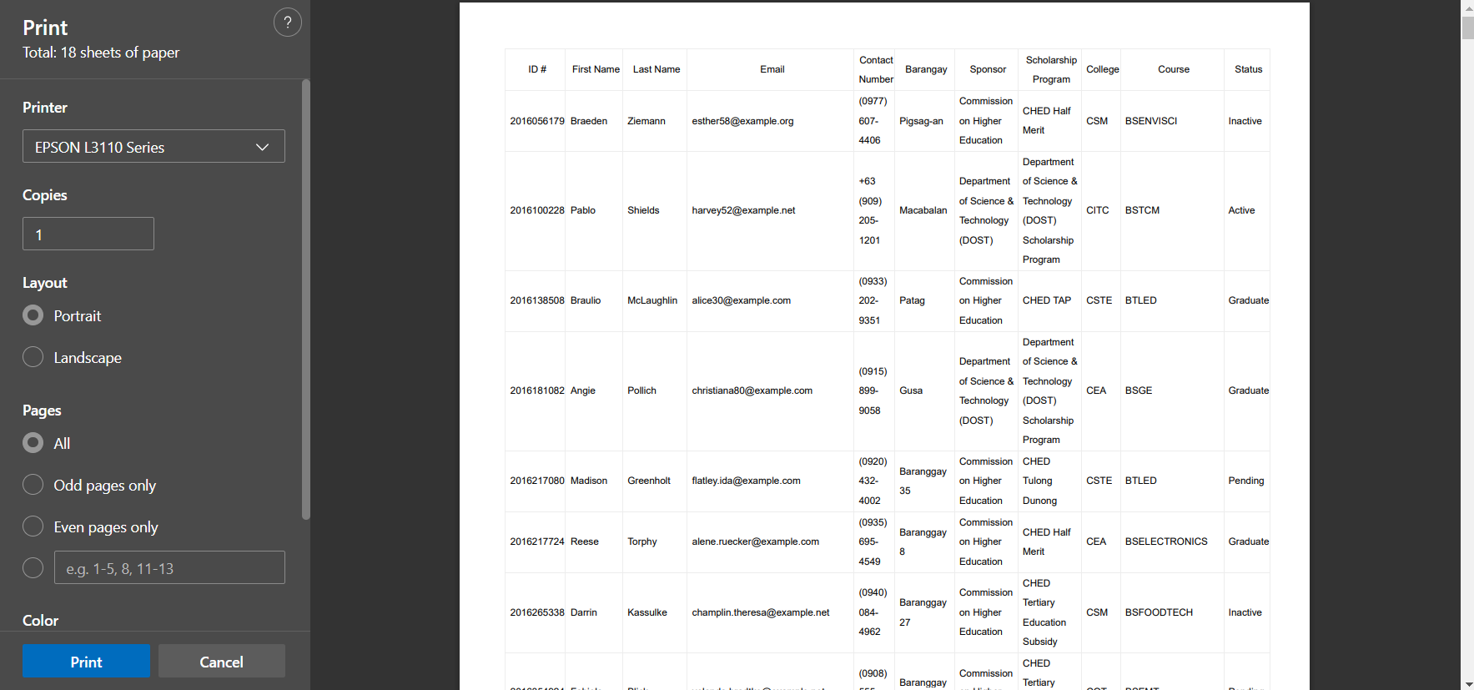

*Figure 11. Print Scholar Report*

**4.1.4 Announcements with SMS Feature**

The system has a feature where ASO staff can create announcements. This announcement may provide a link to their required documentation.

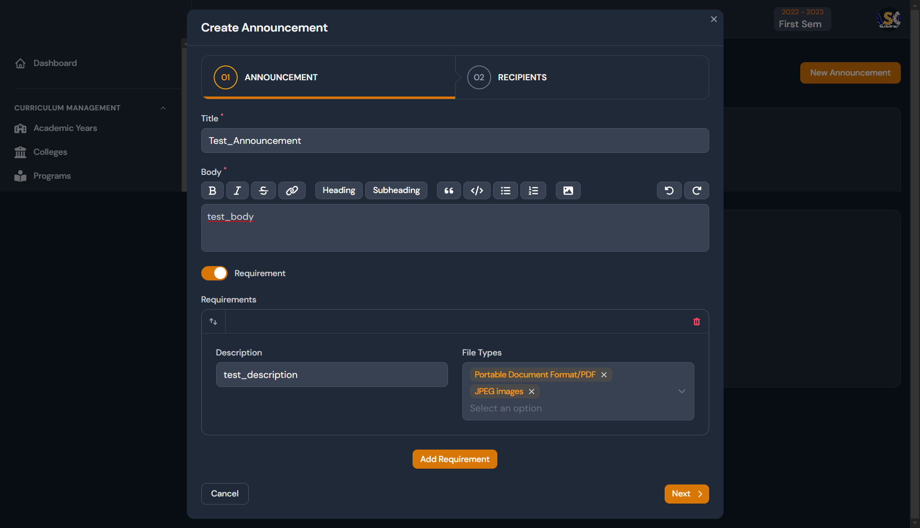

*Figure 12. Creating Announcement*

After creating the announcement, the ASO staff can filter the announcement by scholarship, curriculum, and scholar.

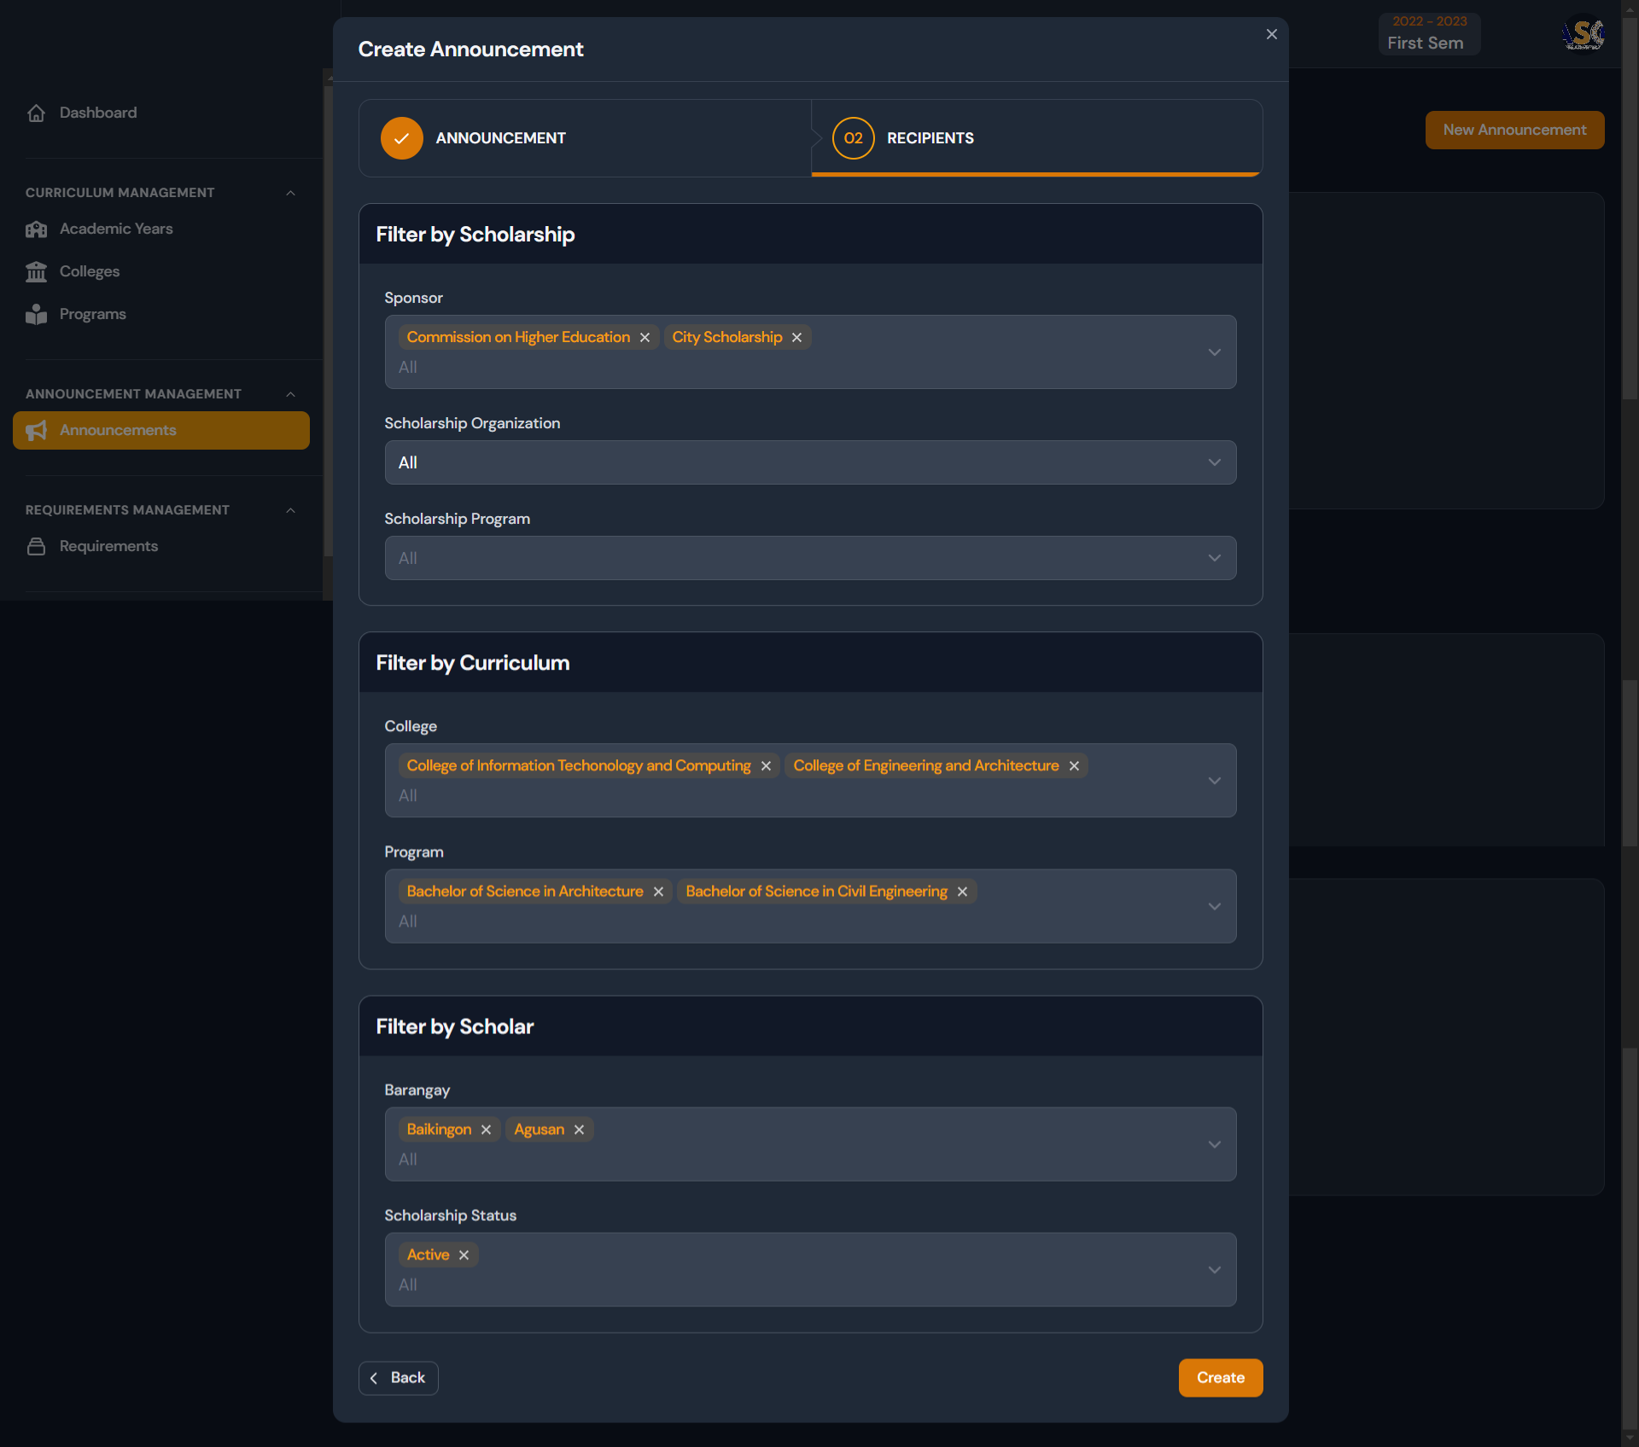

*Figure 13. Creating Announcement, Recipients.*

The SMS module for the ASO staff and administrator can be found by selecting scholar/s in the scholar’s sidebar navigation at the scholarship management module.

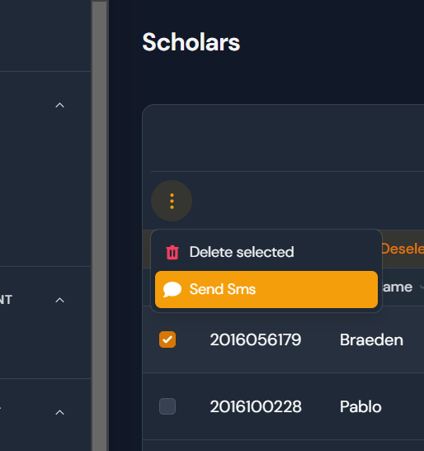

*Figure 14. Send an SMS button.*

The ASO staff can type in an SMS message and click submit. The message will be sent based on the contact number given by the scholar.

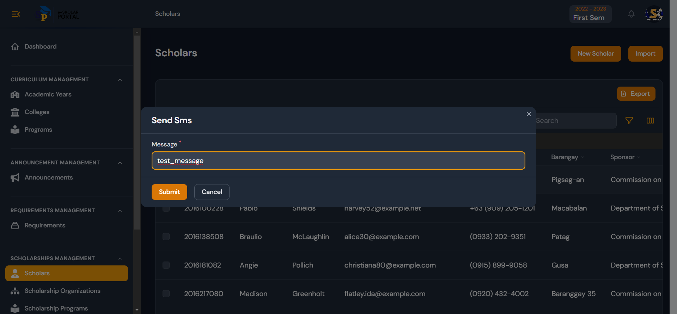

*Figure 15. Send SMS Textbox*

**4.2 Results of the Testing**

**4.2.1 Functionality Test Result**

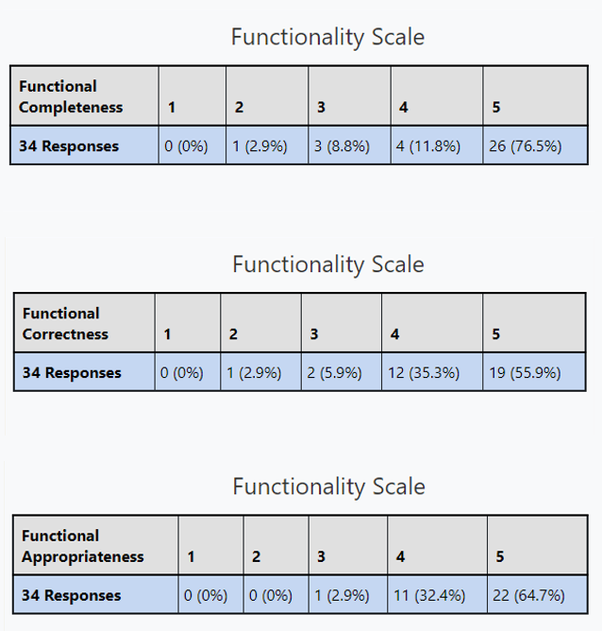

*Figure 16. Functionality Test Results*

**4.2.2 Usability Test Result**

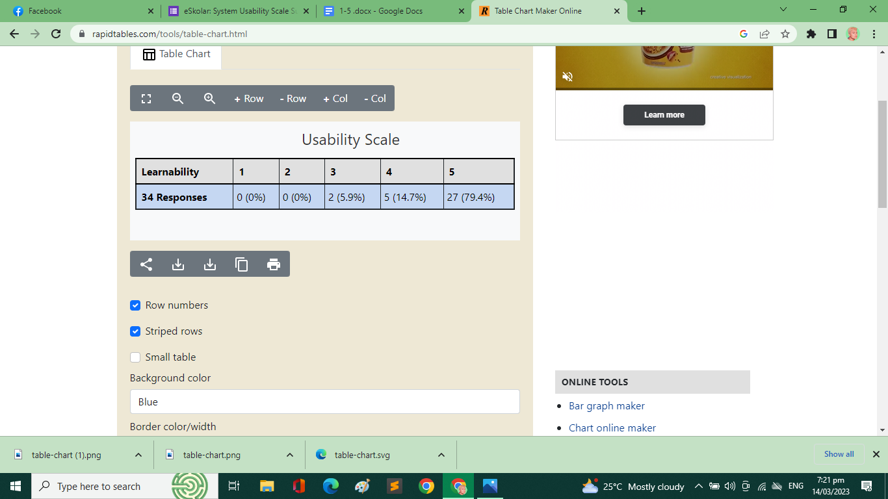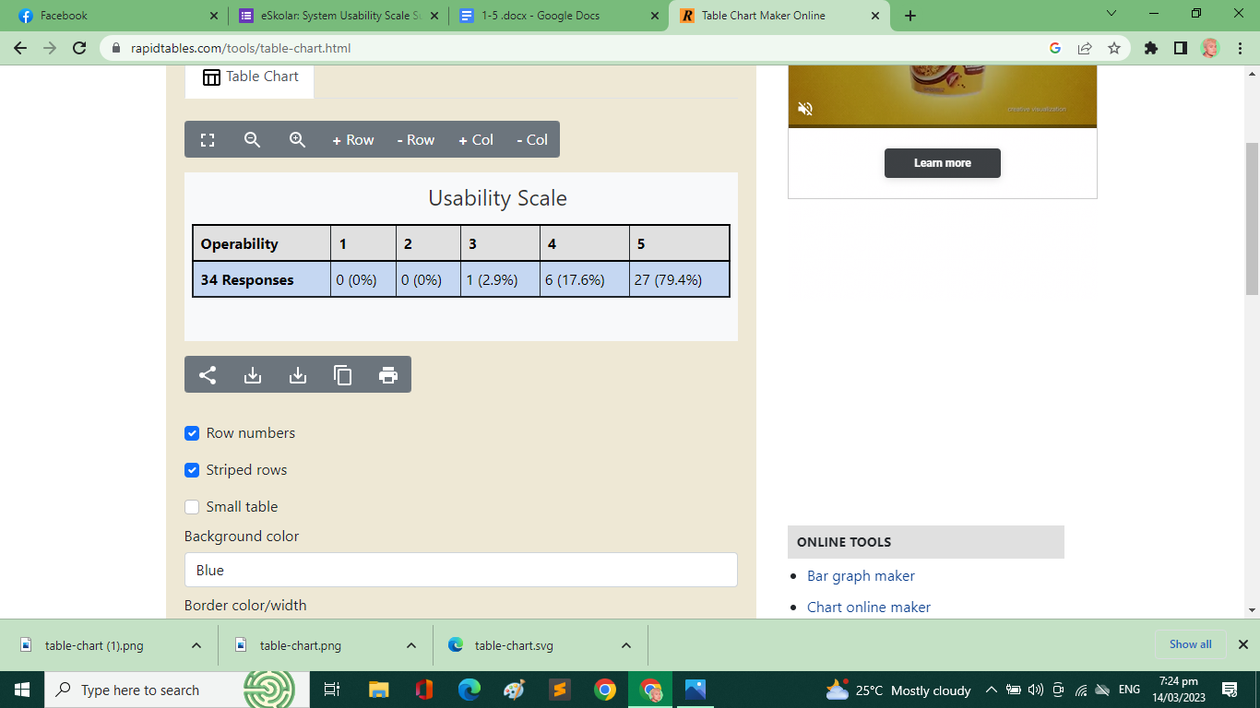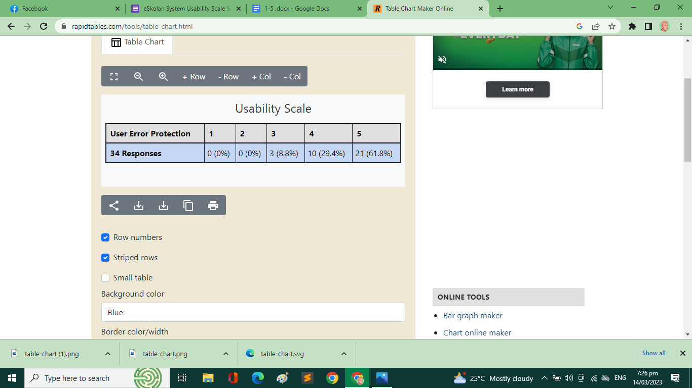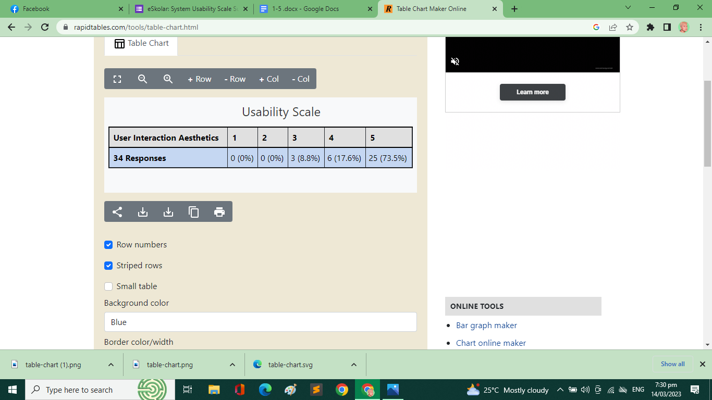 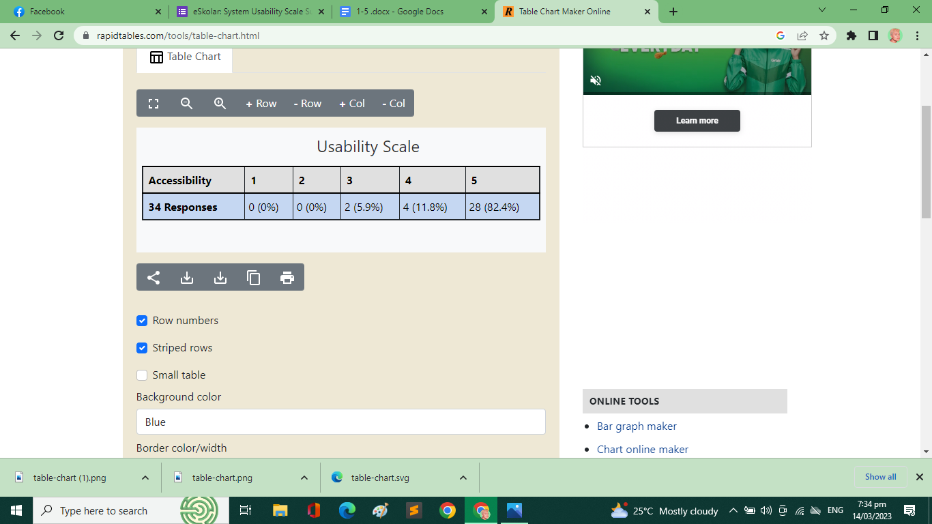

*Figure 17. Usability Test Result of the eSkolar System Survey*

**4.2.3. System Usability Scale Result**

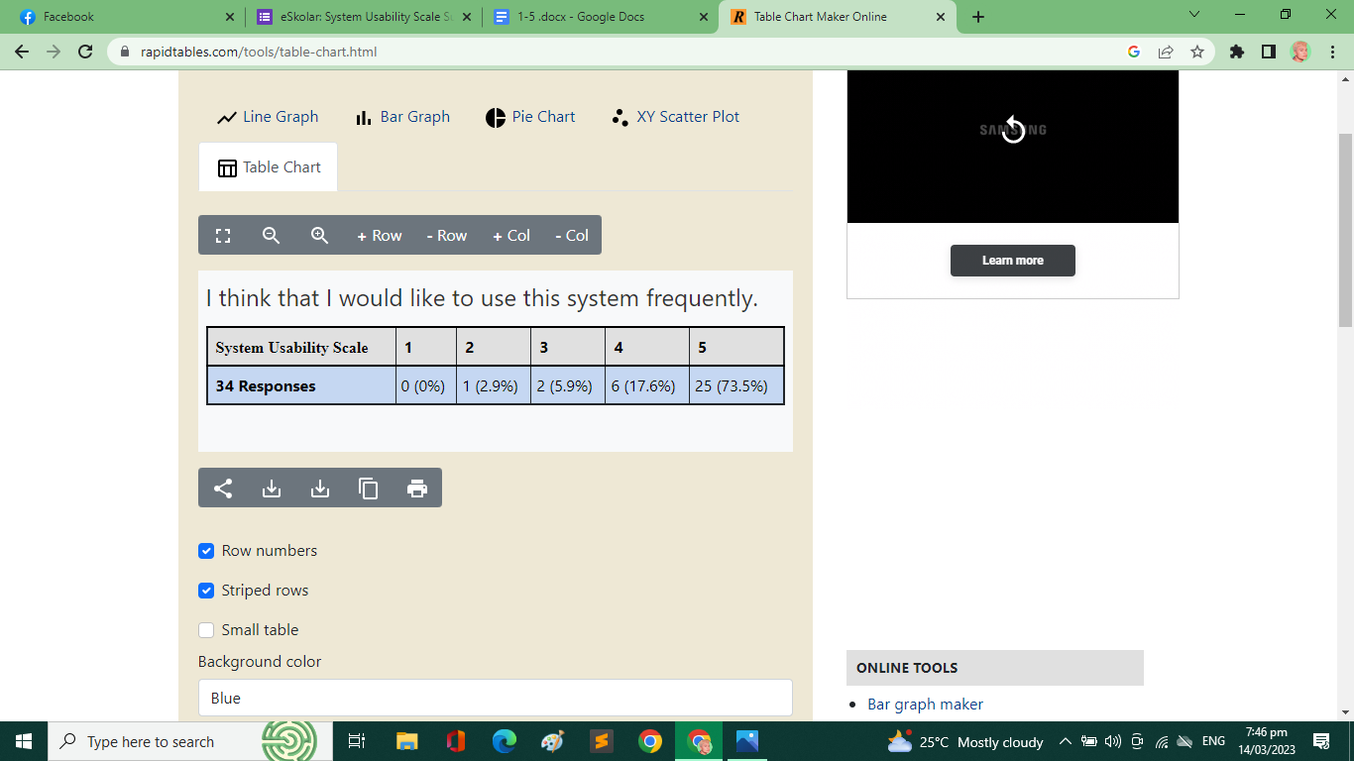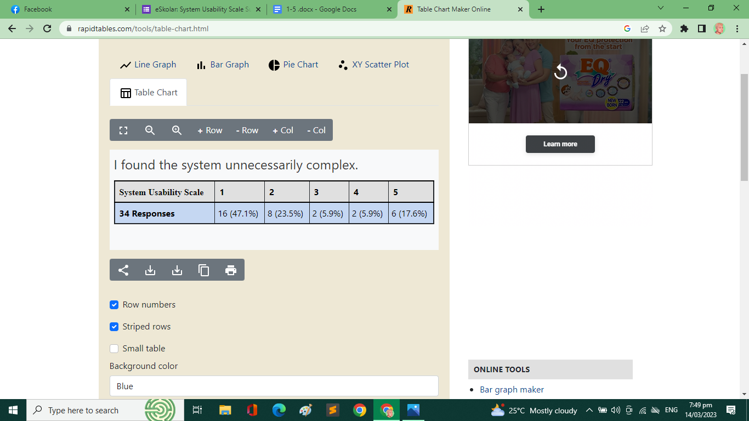

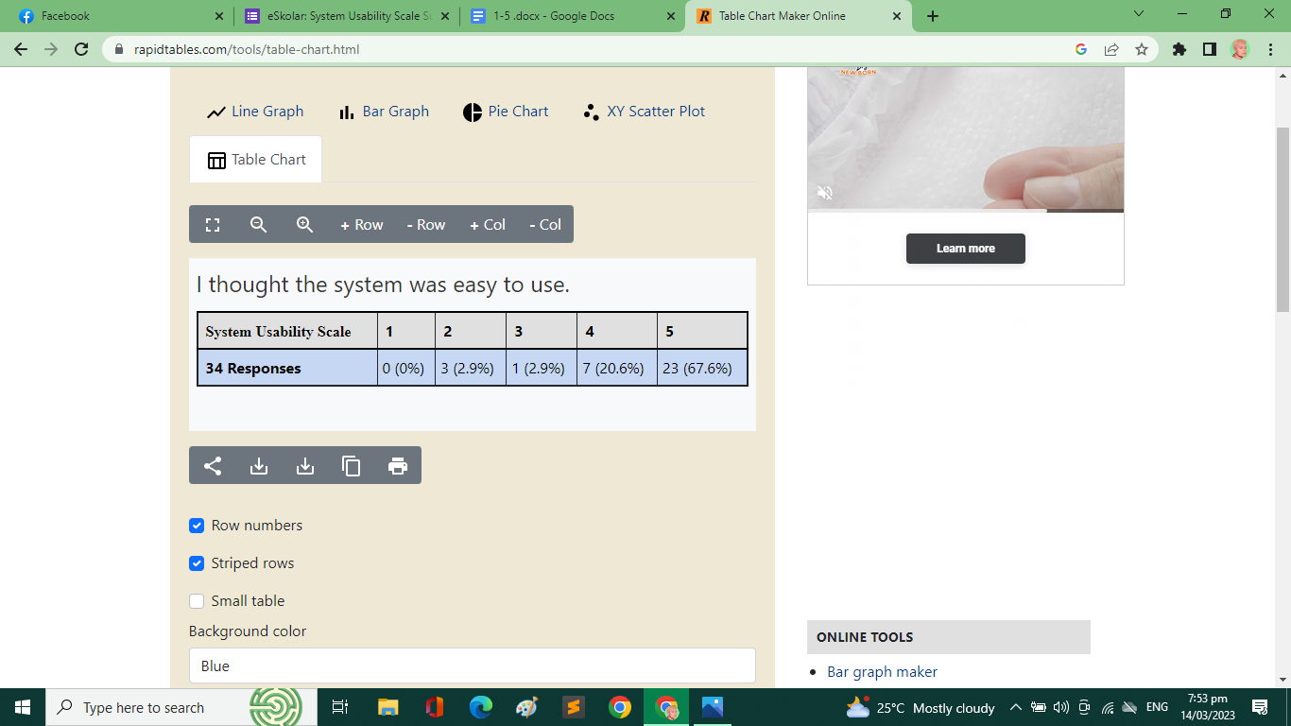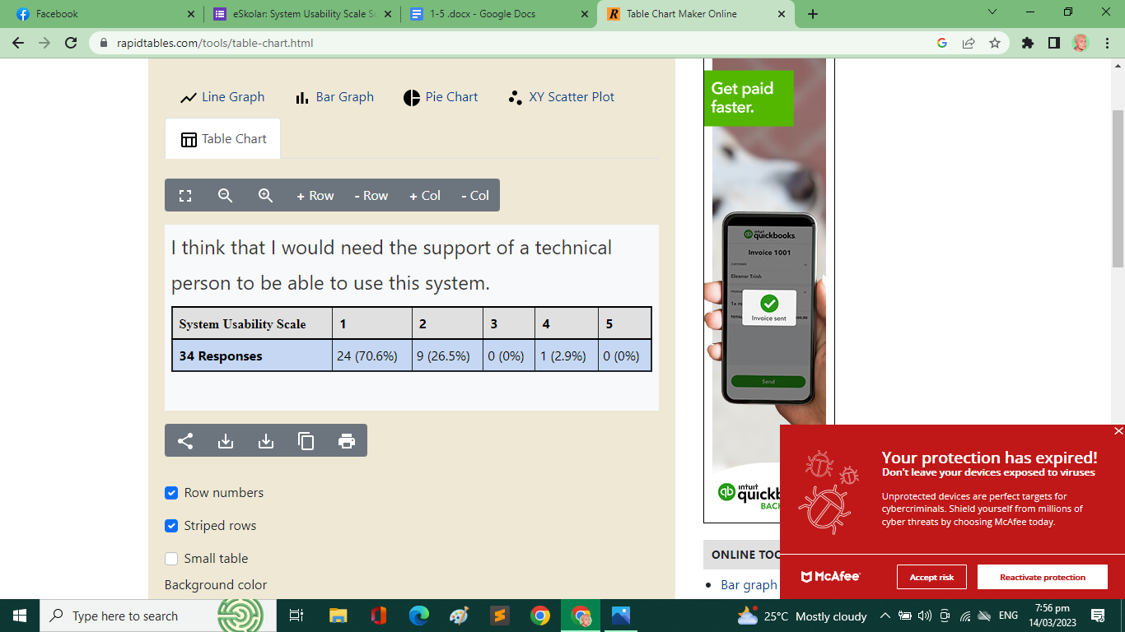

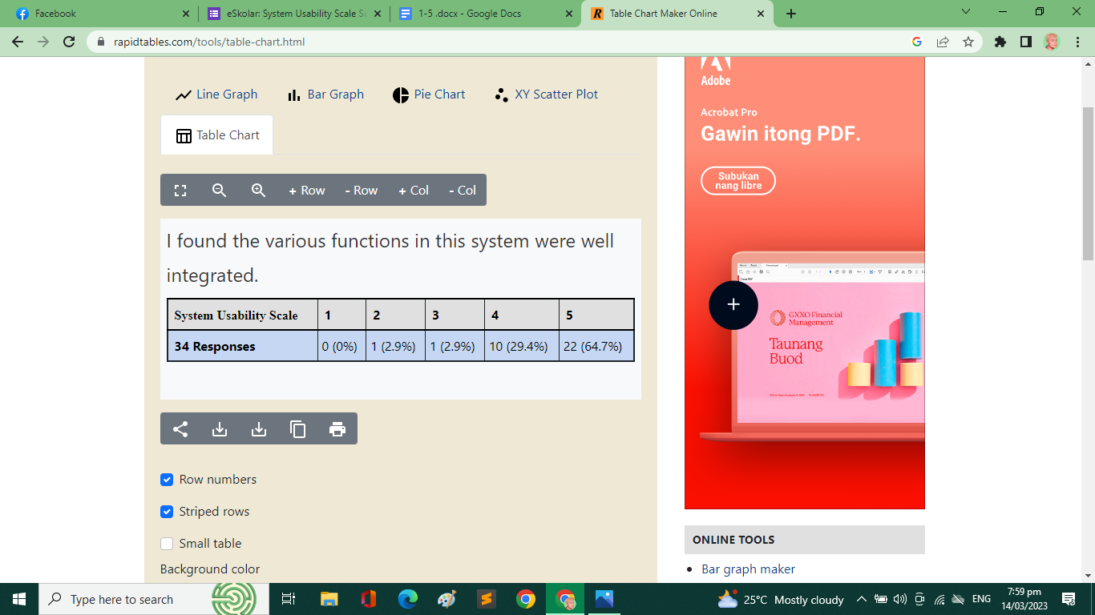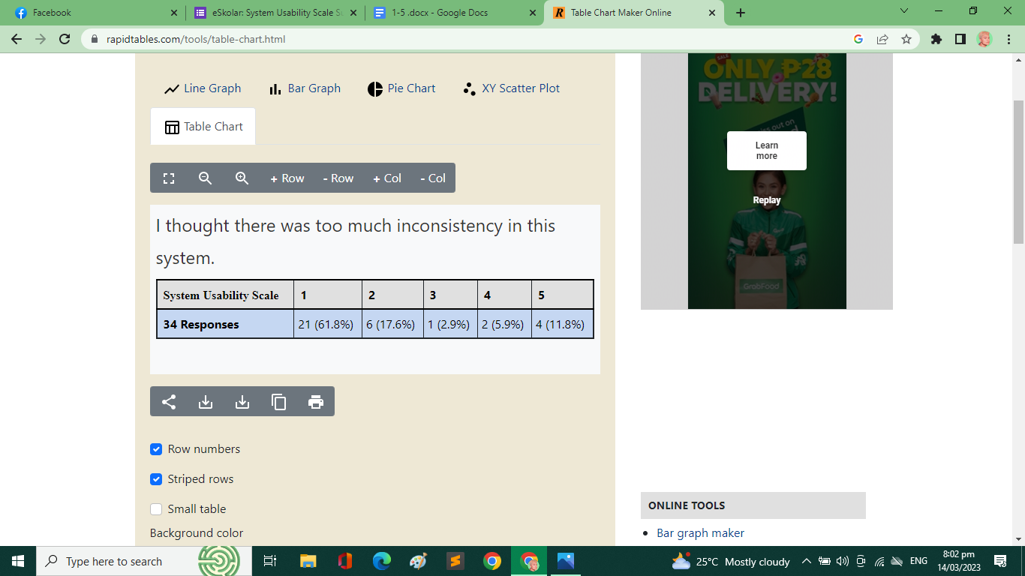

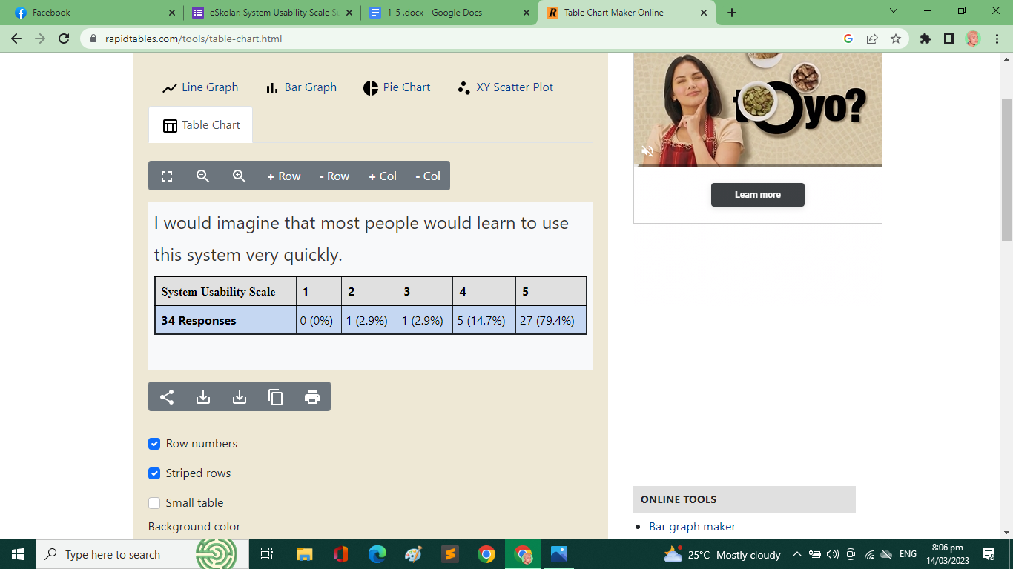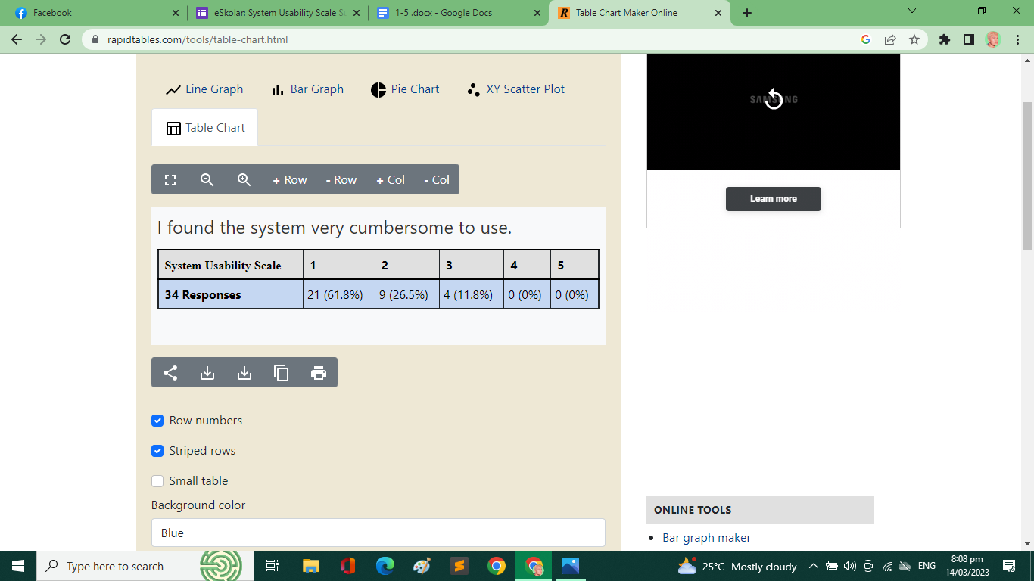

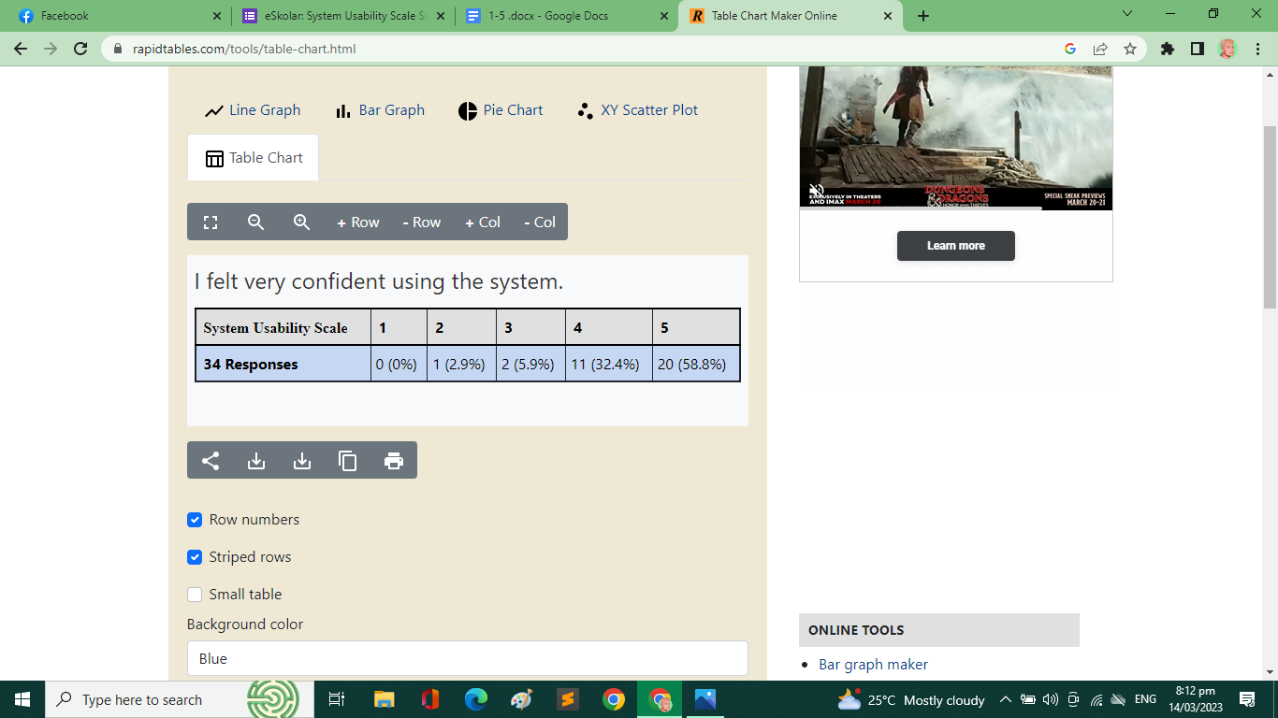 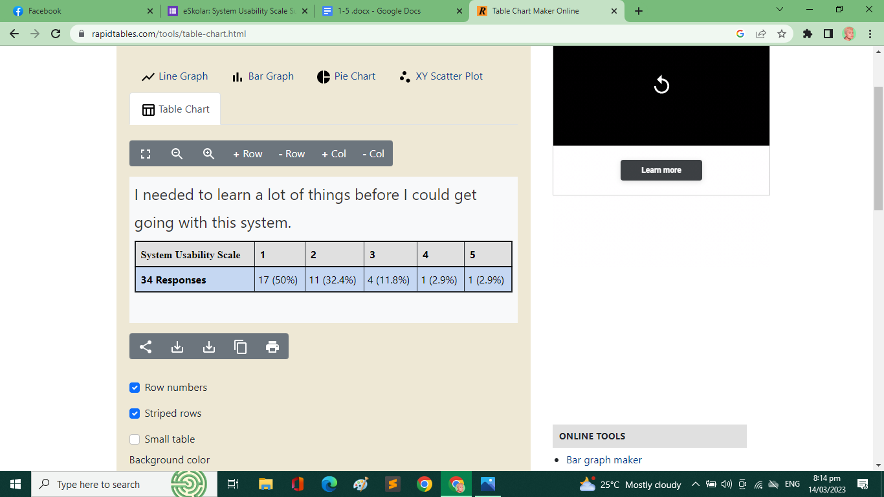

*Figure 18. SUS Test Survey Result of the eSkolar System Survey*

**4.3 Testing Discussion**

Figure 16 shows the results of the functionality test. In the survey, most of the respondents are strongly satisfied with the system in terms of functional completeness, correctness, and appropriateness. Figure 17 shows the results of the usability test. In the survey, most of the respondents are also strongly satisfied with the system in all five categories. Figure 18 shows the bar chart of the System Usability Scale (SUS). In the scale survey, most of the respondents would like to use the system frequently. They find the system consistent, well-integrated, and simple to use. Majority of the respondents believe they would not need technical support to be able to use the system. Despite the respondents needing to learn a lot of the features in the system, based on the survey, they would be able to learn through the process easily.

Based from the figures, the respective surveys show that many of the respondents are overall satisfied of the proposed system. Respondents noted the good functionality, and usability through the way the system runs. Respondents were also pleased with the convenience of having a scholarship system that they can transact

**CHAPTER V**

**CONCLUSION AND RECOMMENDATIONS**

This chapter presents the conclusion and recommendations that the researchers have come up with for the study.

**5.1 Conclusion**

The study was developed to provide a solution to the ongoing scholarship monitoring problems of the USTP Admission and Scholarship Office. Based on the findings and results of the study, it is concluded that the development of an online portal system for the scholarship unit would be beneficial and improve ASO services efficiently and conveniently in scholarship monitoring, document requirement-tracking, and information dissemination. ASO staff can work more efficiently, and conveniently track and conduct monitoring of its scholars. As such, the proposed system is a upgrade from the tedious, manual process of encoding scholarship data to Excel spreadsheet, which can benefit not only for ASO but also for scholars and the scholarship organizations that represent each scholarship grant.

**5.2 Recommendations**

Based on the findings of the study, future researchers who wish to continue this related study are recommended to create or improve the website application by providing a helpdesk tool in catering academic and non-academic concerns of scholars. Additionally, with the recent implementation of the USS membership card, a card mandated by the ASO to its scholars, the QR code functionality in the card can be utilized by the system to track activity and event attendance of scholars in scholarship organizations. In addition, a mobile application of this sytem can be developed in future studies to further expand the system’s usage to its respective studies.

**REFERENCES**

Alvaro, P. A. (2021). Scholarship Information Management System with Academic

Performance Predictor and Decision Support System. <http://tjct.isujournals.ph/index.php/tjct/article/view/26>

Paideya, Vino & Dhunpath, Rubby. (2018). Student Academic Monitoring and

Support in Higher Education: A Systems Thinking Perspective. Journal of Student Affairs in Africa. 6. 10.24085/jsaa.v6i1.3064.

Prijayanti, Dian & Artha, Emilya & Arumi, Endah. (2020). Web-Based Monitoring

Information System for Scholarship Holder. 10.2991/assehr.k.200529.256.

Sauser, Eric Irvin, "Scholarship management system" (2011). Honors Program

Theses. 20. <https://scholarworks.uni.edu/hpt/20>

Rand, D., & Stager, L. (2018). Promoting and Tracking Institutional Scholarship

with Implementation of a Librarian-Curated Digital Repository and Research Information Management System. Medical reference services quarterly, 37(4), 375–385. <https://doi.org/10.1080/02763869.2018.1514904>

Engr. Ariel M. Marave. (2019). Online Scholarship Application and Record

Management System for AYZ City. International Journal of Recent Innovations in Academic Research, 3(3), 32–56. Retrieved from <https://www.ijriar.com/index.php/ijriar/article/view/186>

Jibrin, M. A. (2016). Development of E-Scholarship System.

<https://www.semanticscholar.org/paper/Development-of-E-Scholarship-System-Jibrin-Musa/7501c8c2740568c026500079f1a50ab4225104d3>

Mohammed, Mohammed & Kadhim, Mahir & Fuad, Ahmed & Jaber, Mustafa.

(2014). Follow up system for directorate of scholarship and cultural relations in Iraq. I4CT 2014 - 1st International Conference on Computer, Communications, and Control Technology, Proceedings. 182-187. 10.1109/I4CT.2014.6914171.

“10 Disadvantages of Microsoft Excel - Javatpoint.” Www.javatpoint.com,

<https://www.javatpoint.com/10-disadvantages-of-microsoft-excel>.

CDO City Government. *City Scholarships Office*.

<http://cityscholar.cagayandeoro.gov.ph:8080/>.

“National Scholarship Portal.” *Home - National Scholarship Portal*,

<https://scholarships.gov.in/>.

“Scholarship Management Portal.” *CSM Technologies*,

<https://www.csm.tech/resource-details/scholarship-management-portal/>.

“Scholar Tracking System (CSR Products).” *Buddy4study*,

<https://csr.buddy4study.com/sts>.

Brooke, John. (1995). SUS: A quick and dirty usability scale. Usability Eval. Ind..

189.

Appendix A

User Manual

|  |  |
| --- | --- |
|  | This user manual provides an overview of the software that assists the administration, scholar organization, and students in accessing this website. |

1. 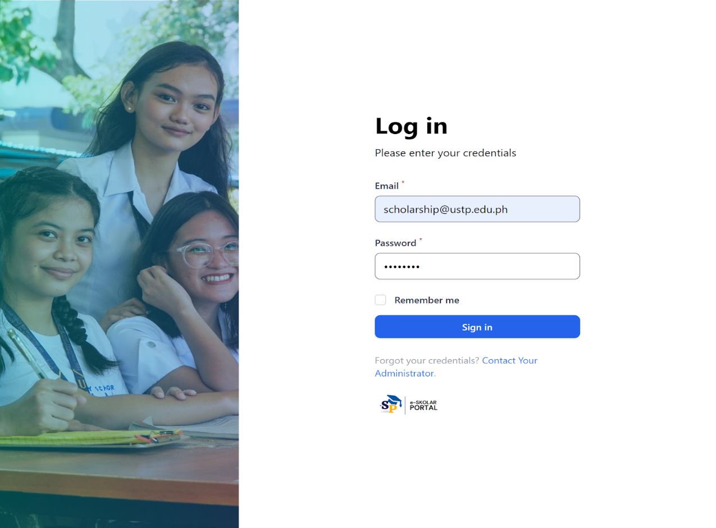How to Login/logout
2. 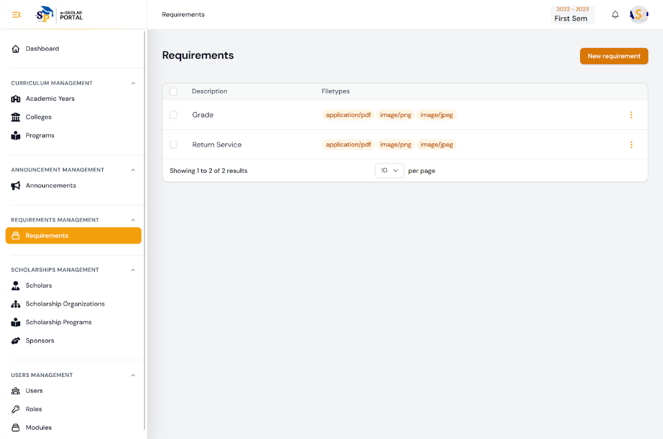How to manage requirements

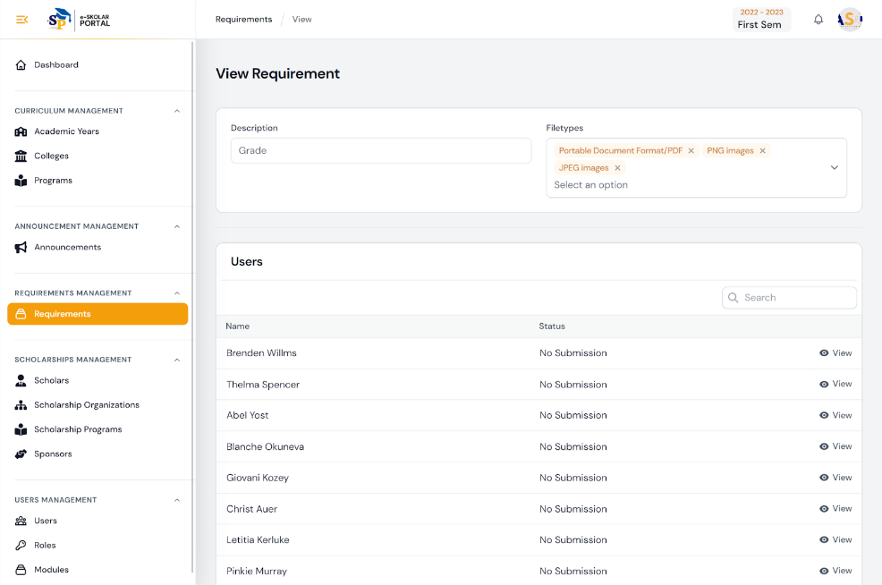

1. 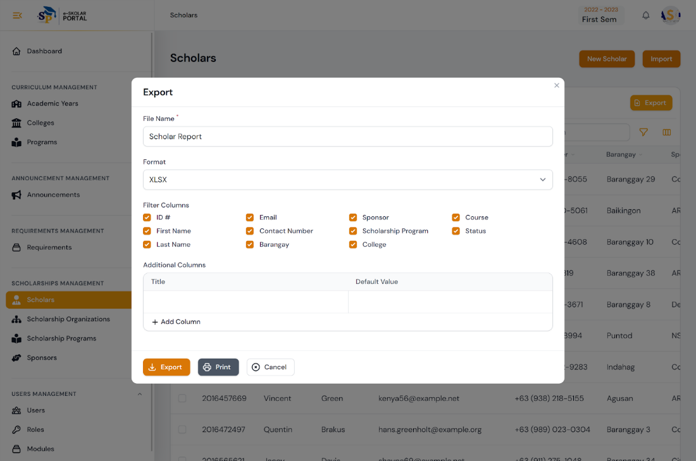How to generate scholar reports

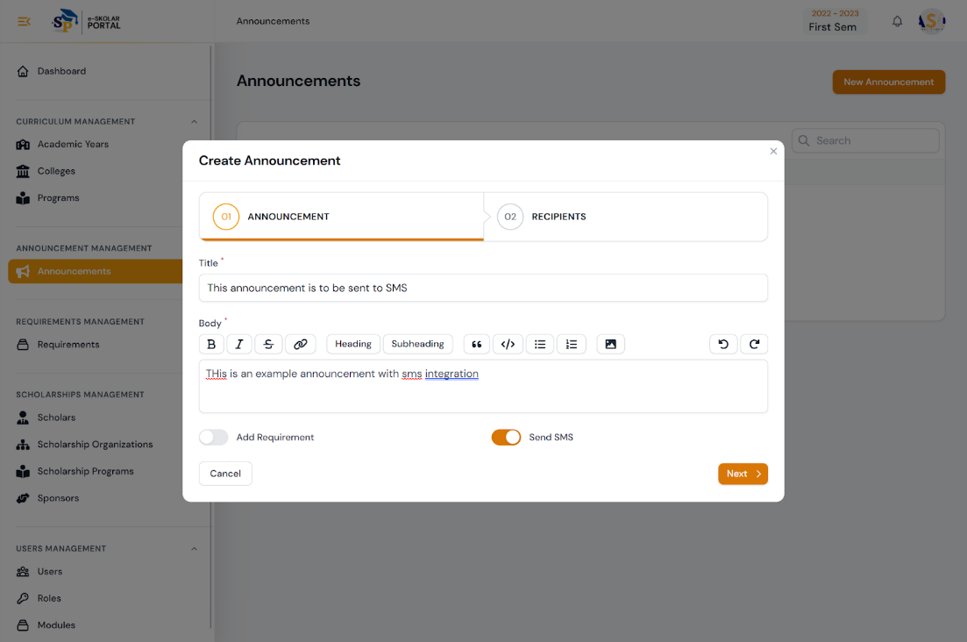

1. How manage announcements with SMS

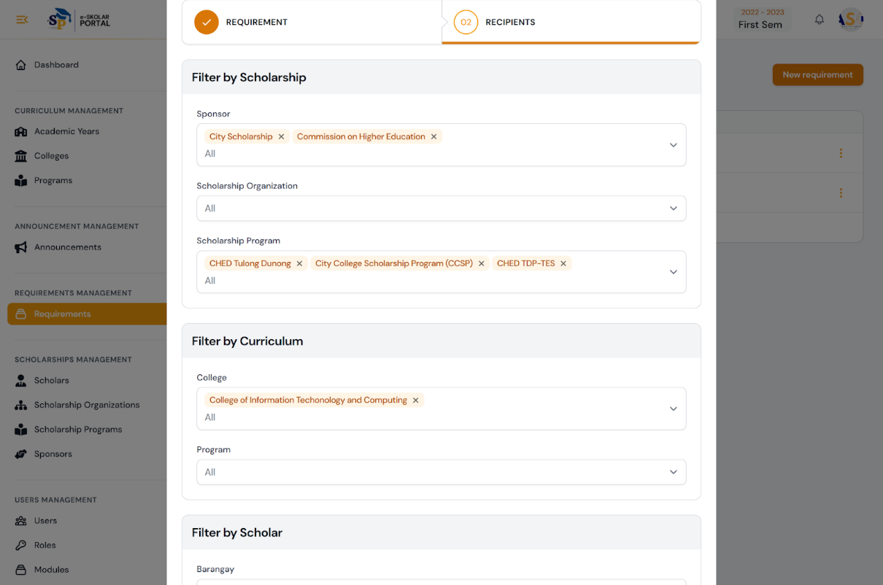

1. 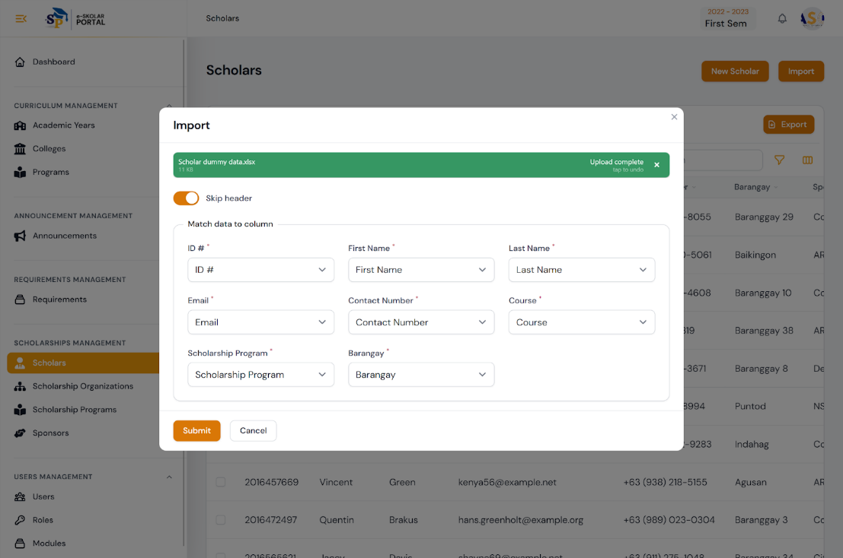How to input .csv or excel files to the system

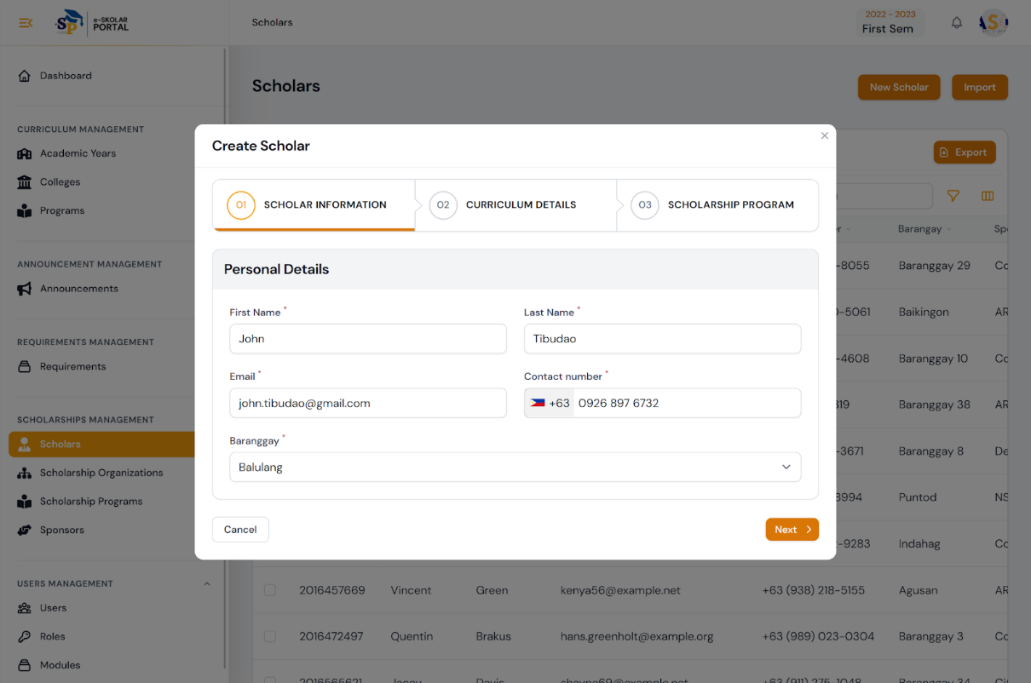6. How to create a new scholar account in the system

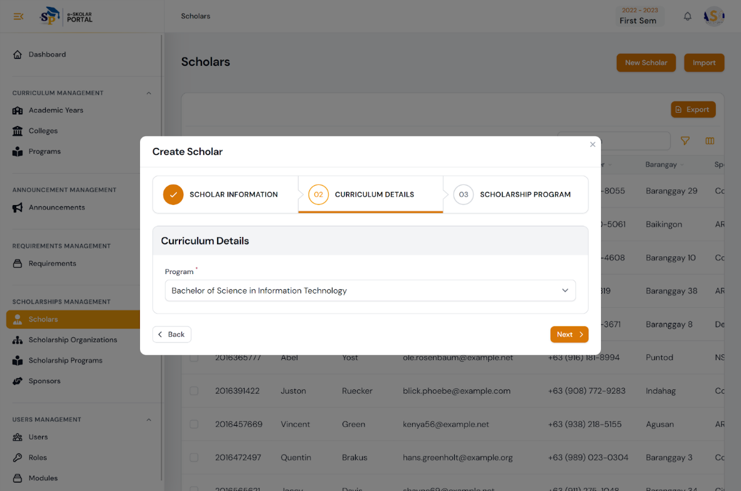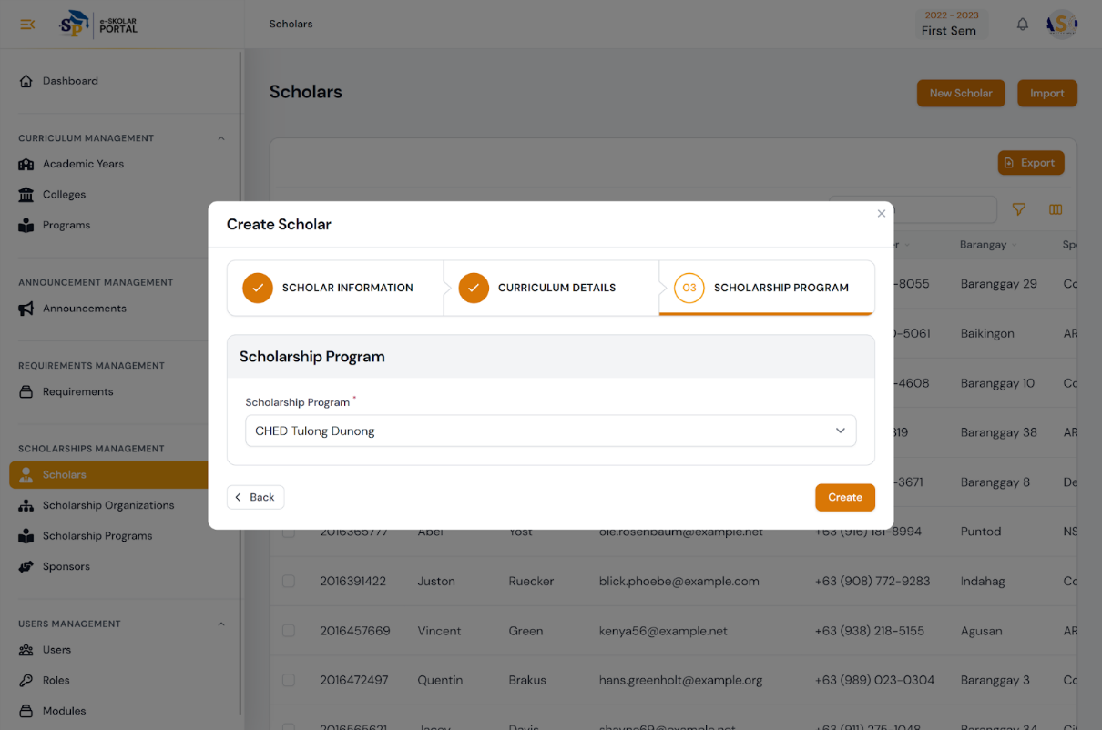

1. 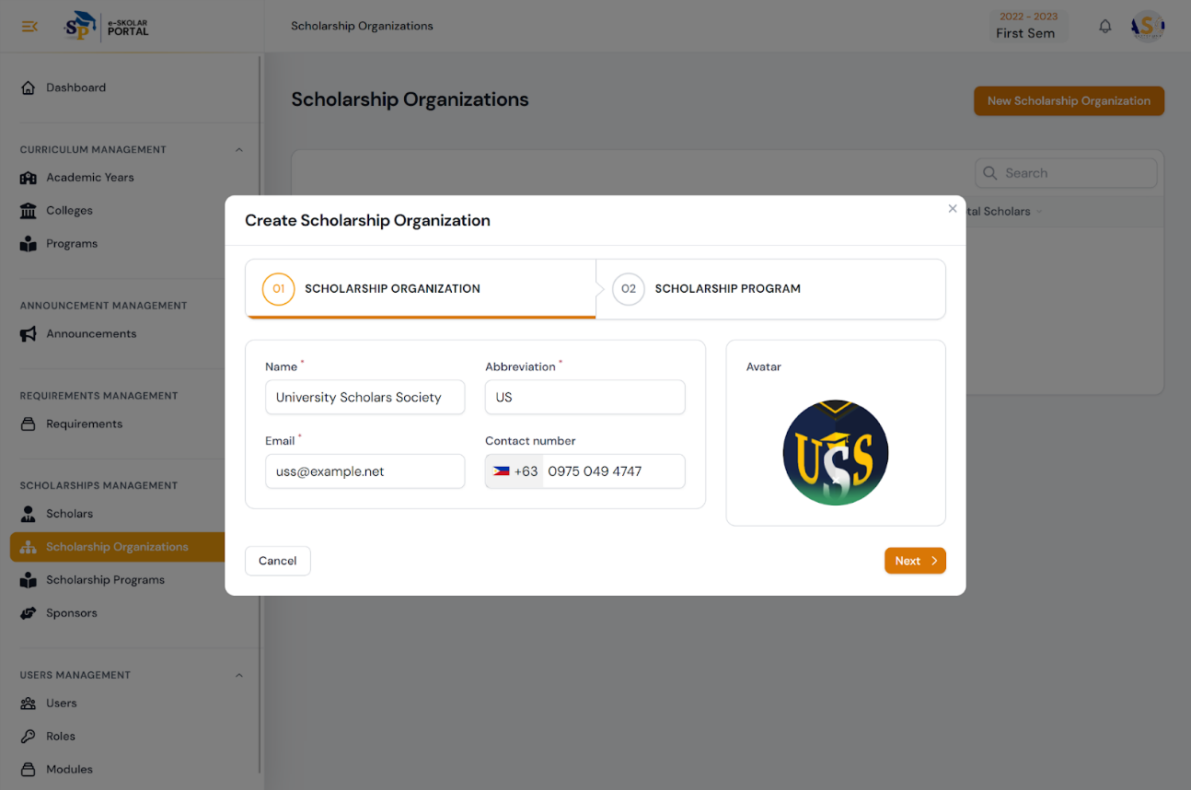How to create a new scholar organization account in the system

8. How to set roles and permissions for users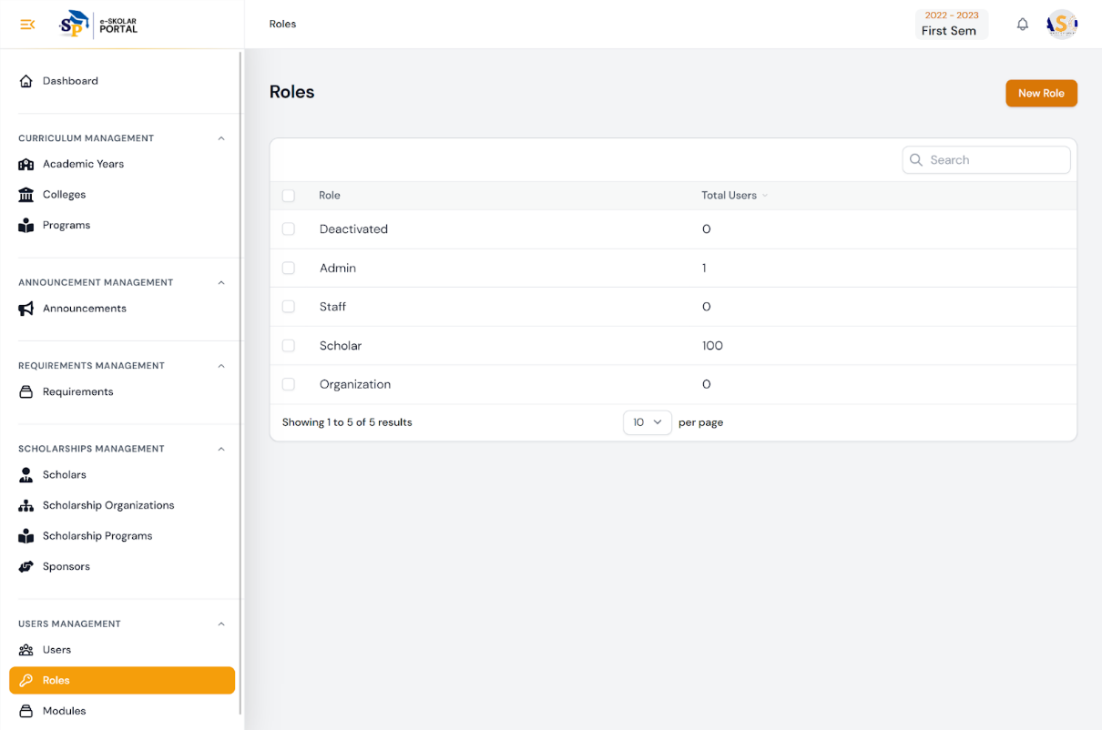

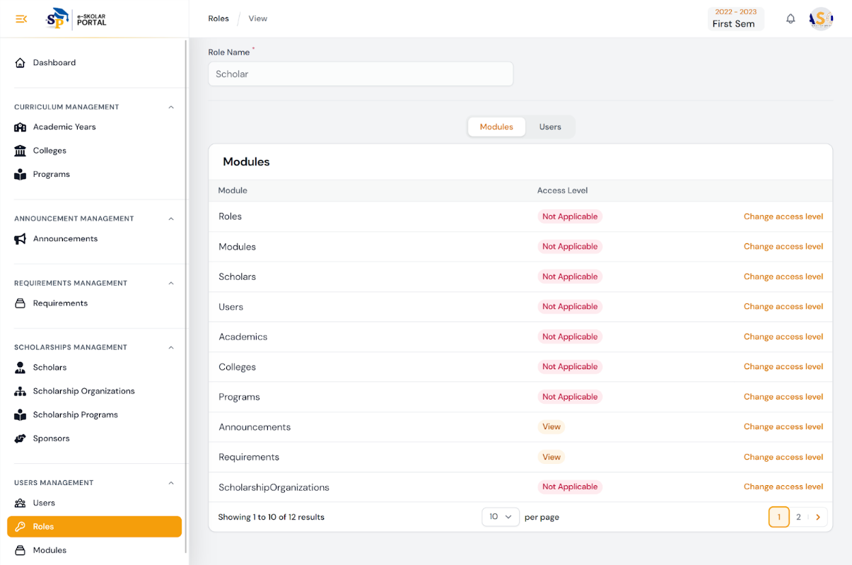

APPENDIX B:

Code Snippets

1. Login

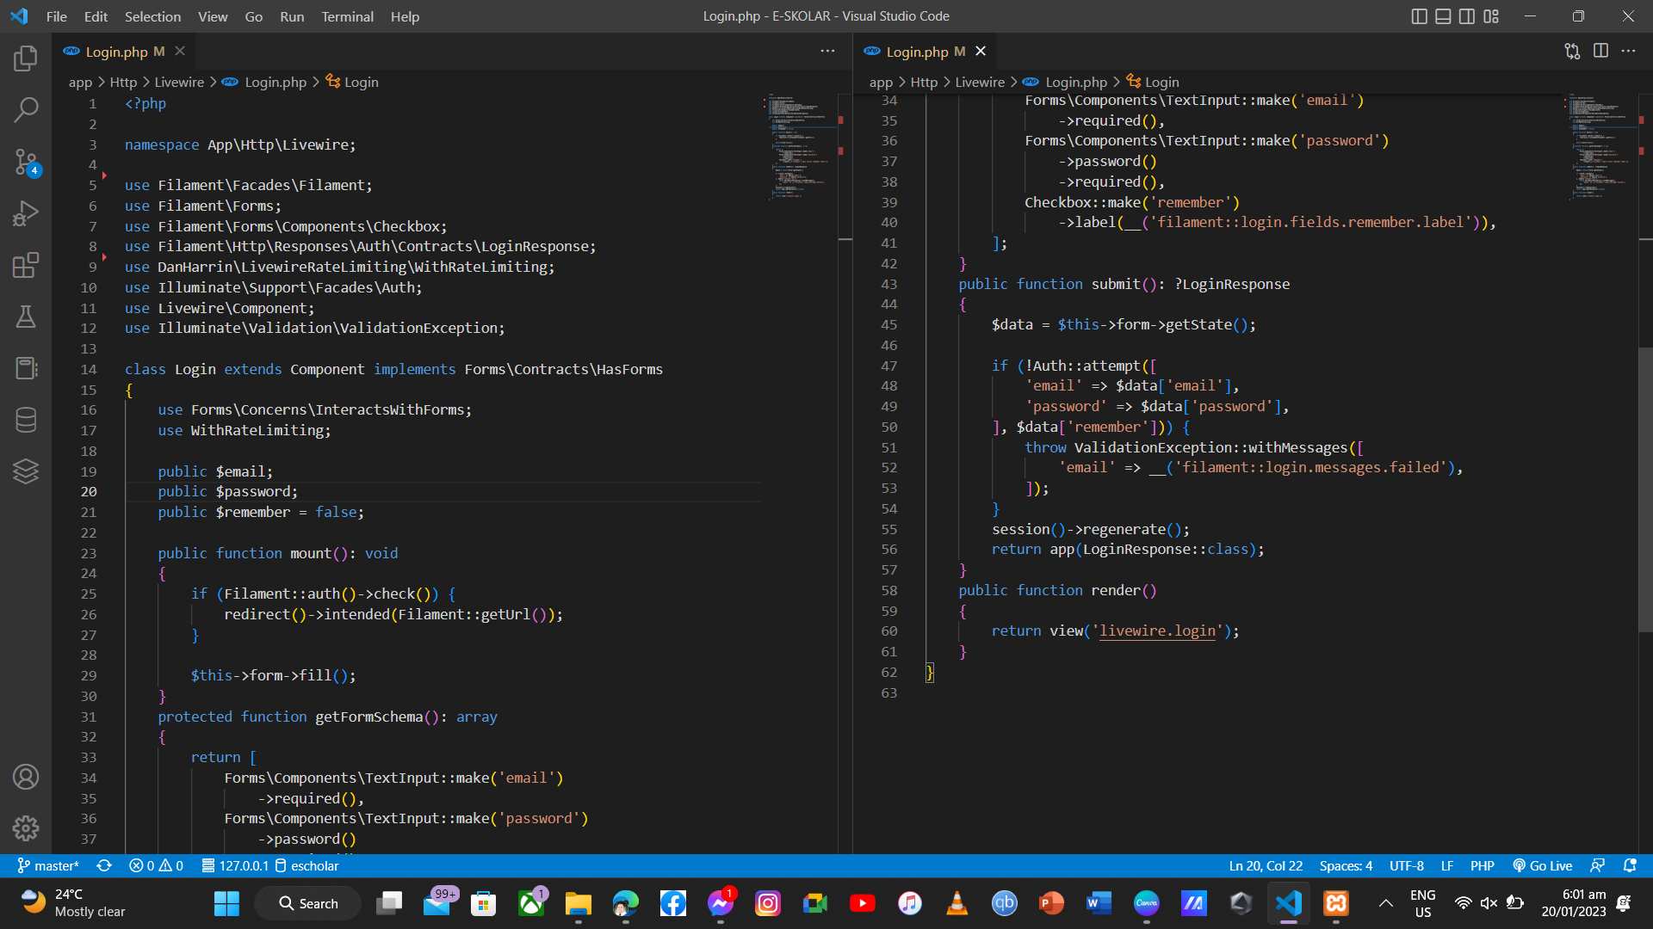

1. Requirement Management

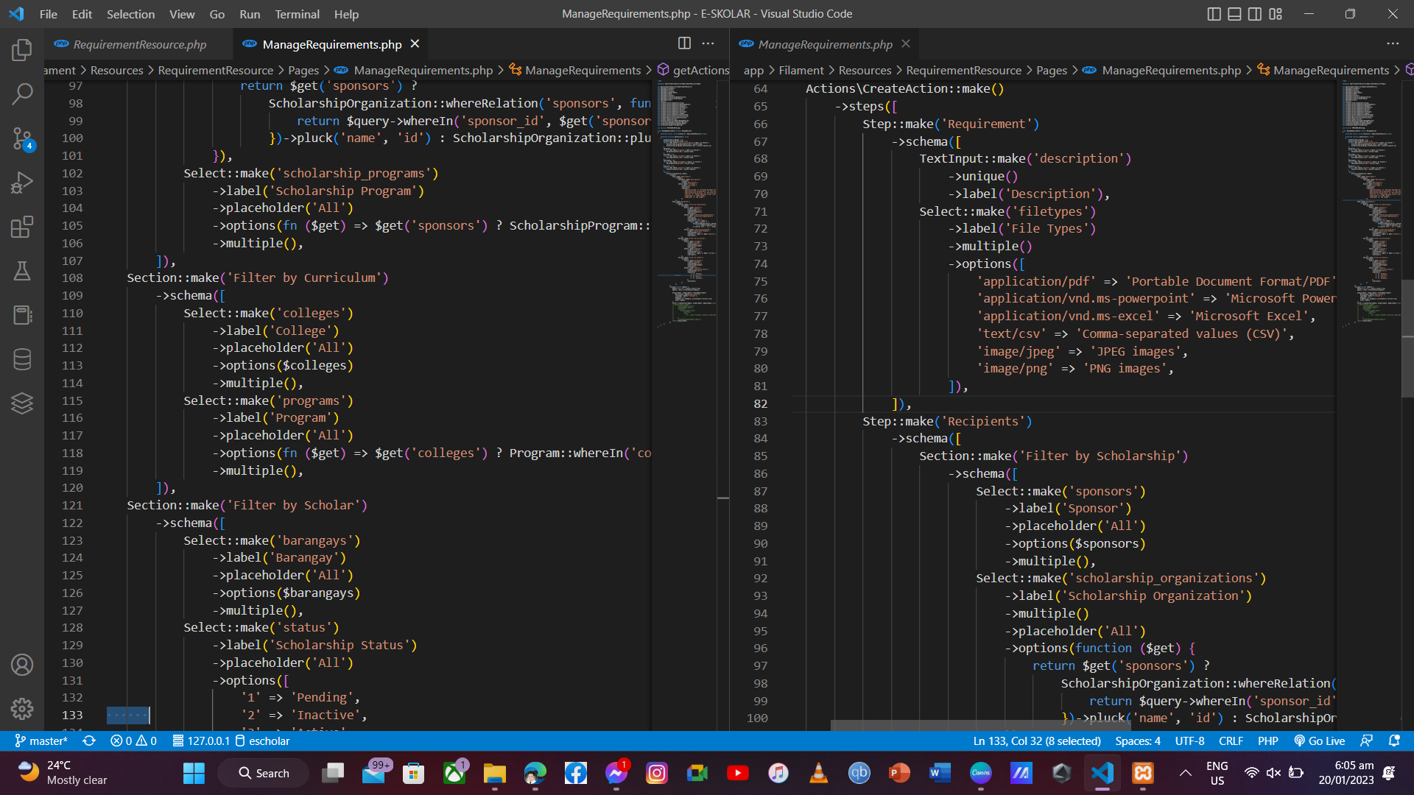

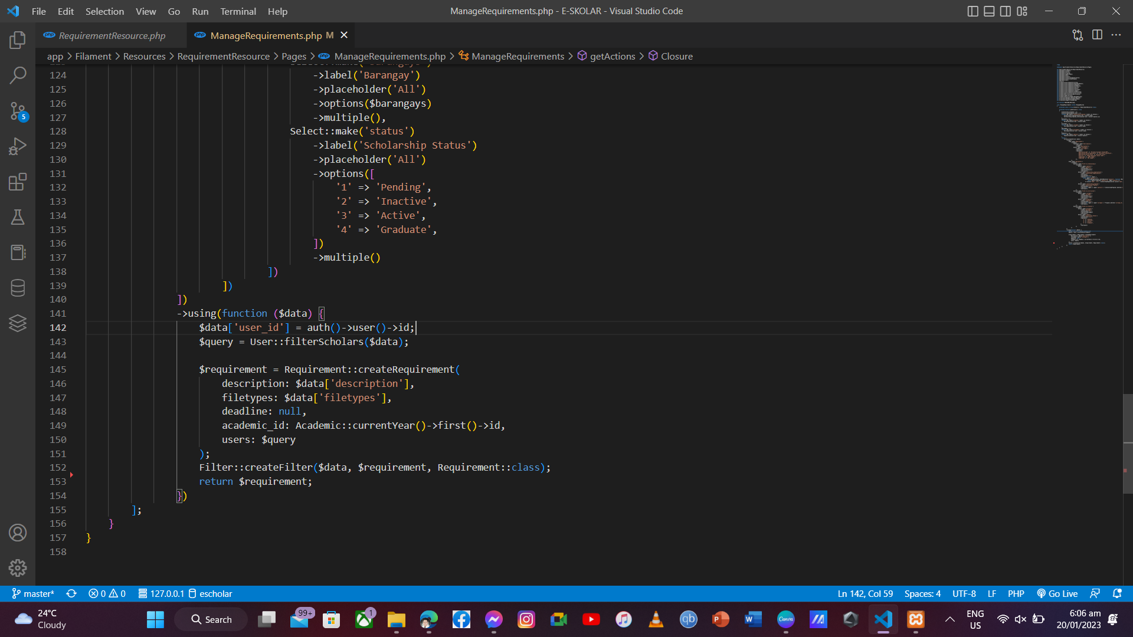

1. Submitting of Requirement

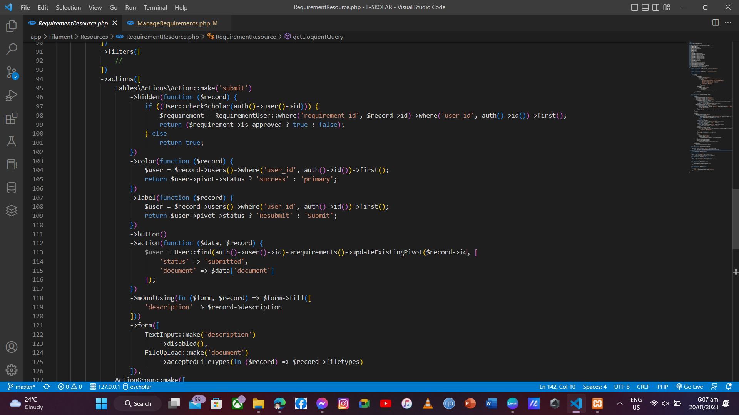

1. Generating of reports

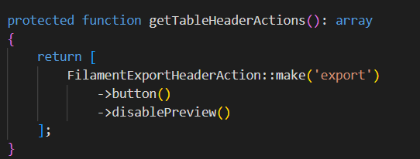

1. Announcement Resource with SMS

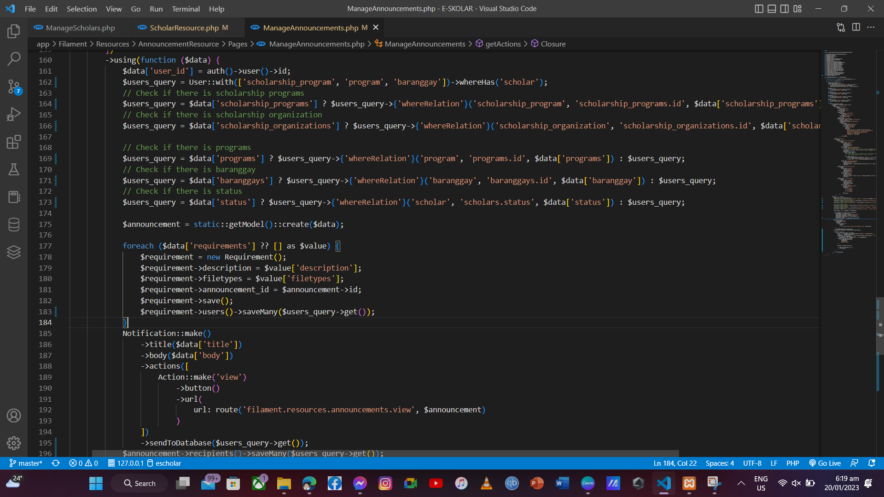

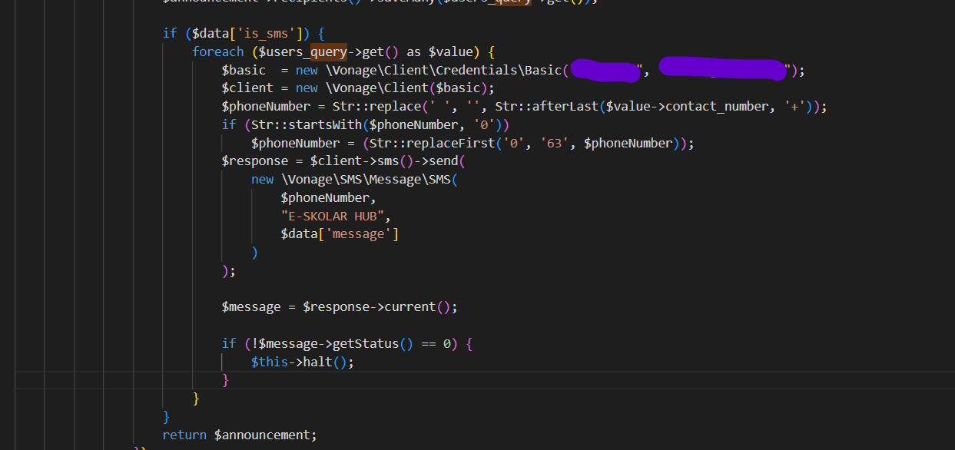

APPENDIX C:

Communication Letters

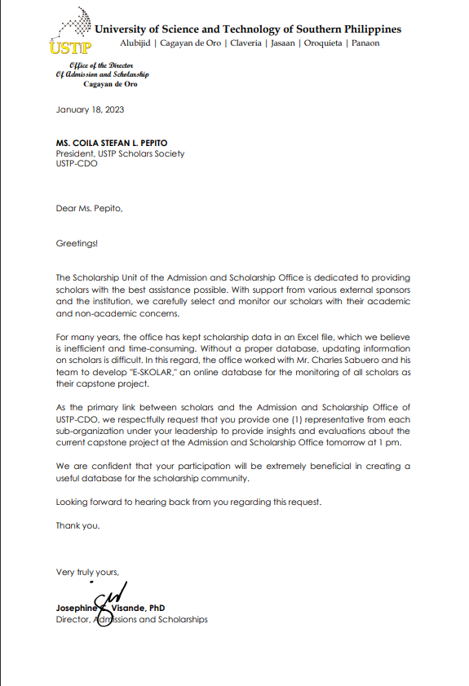

APPENDIX D:

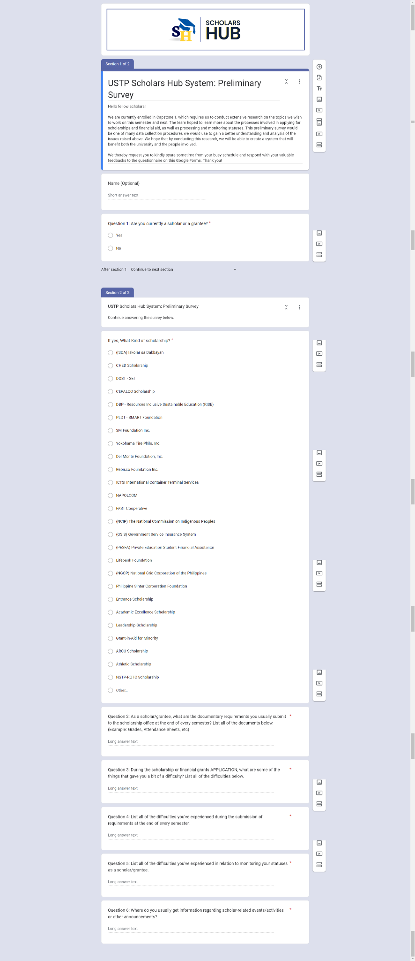Survey Forms

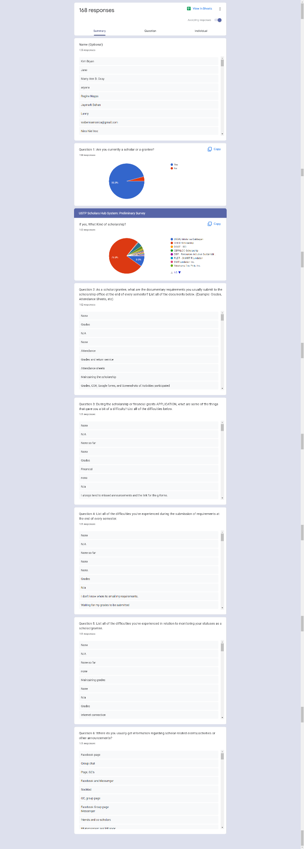







APPENDIX E

Documentation

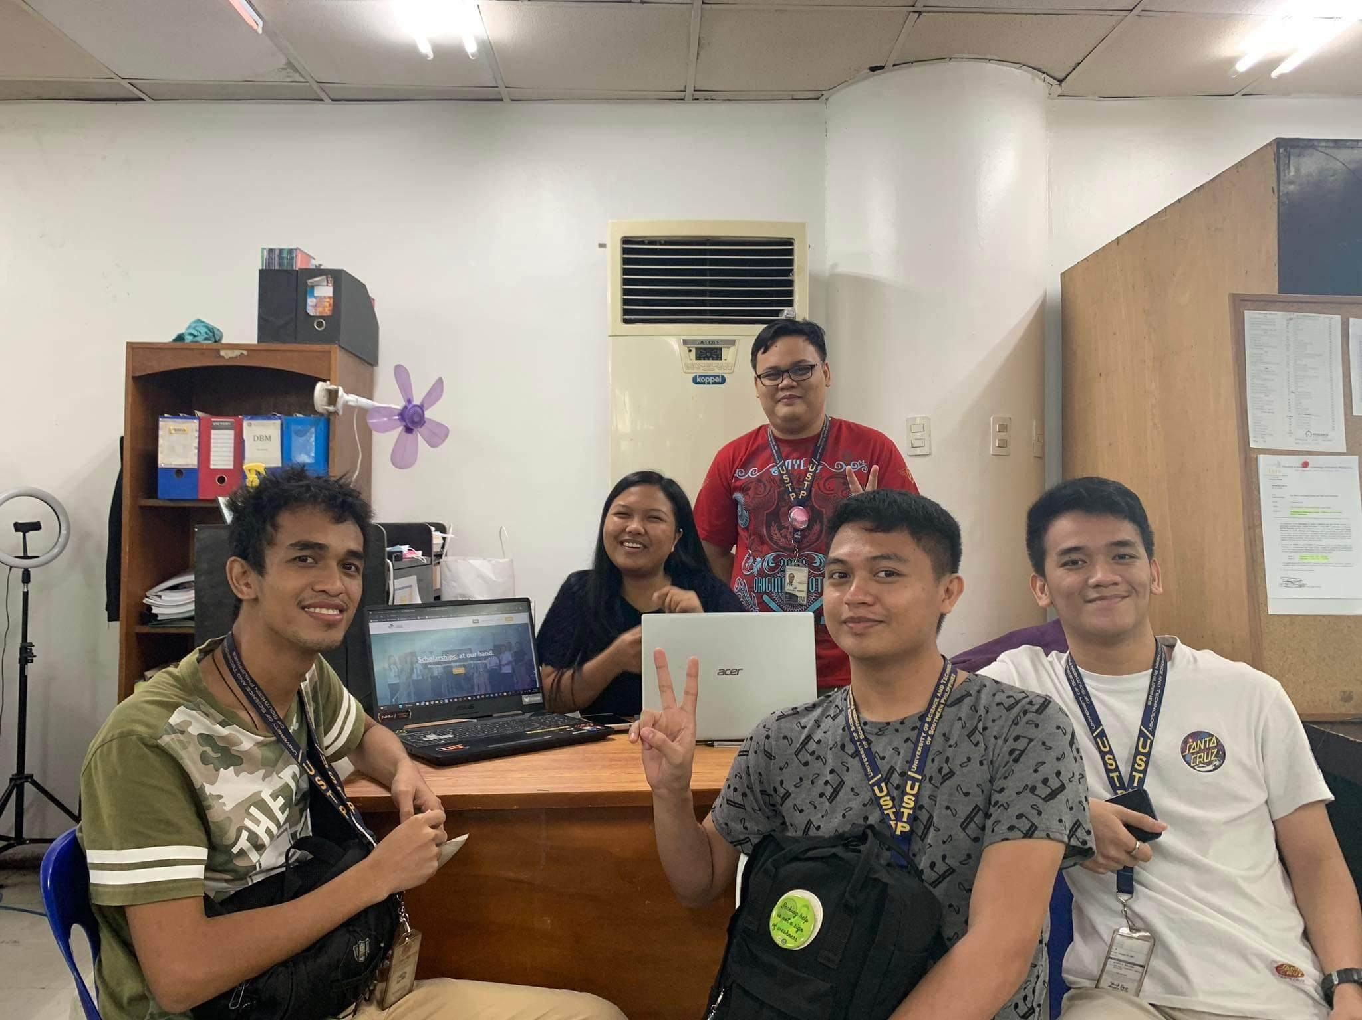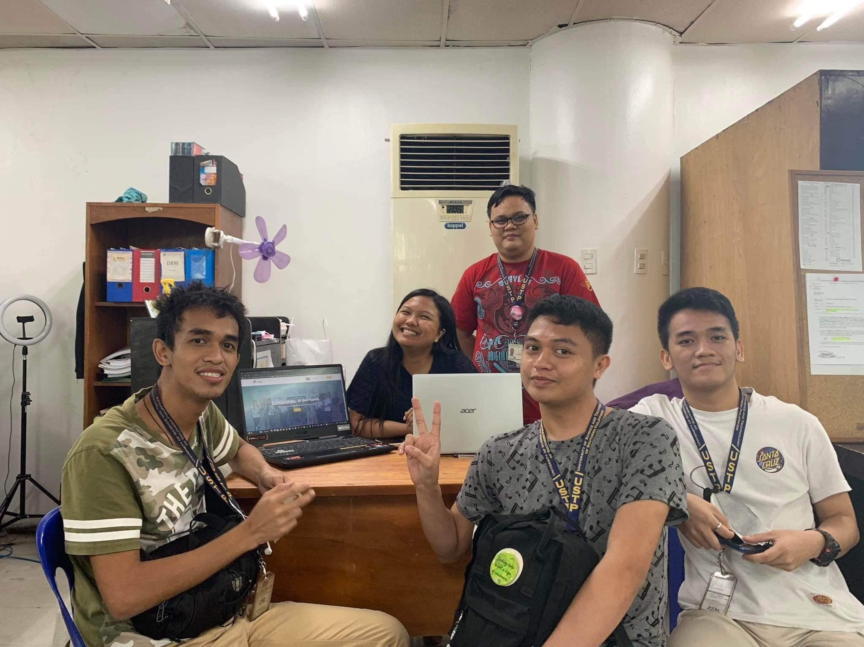

Consultation with the adviser

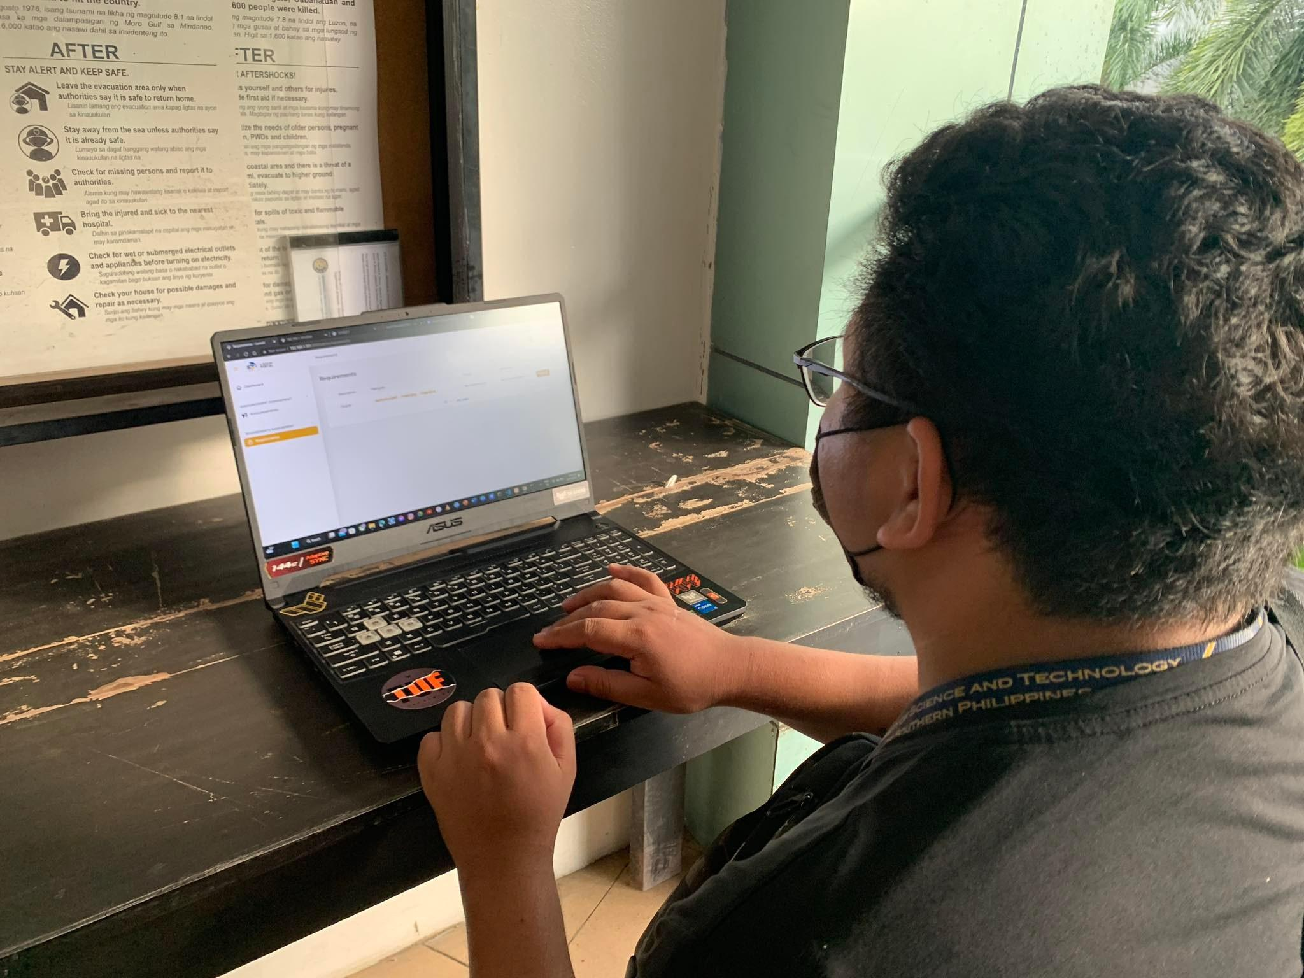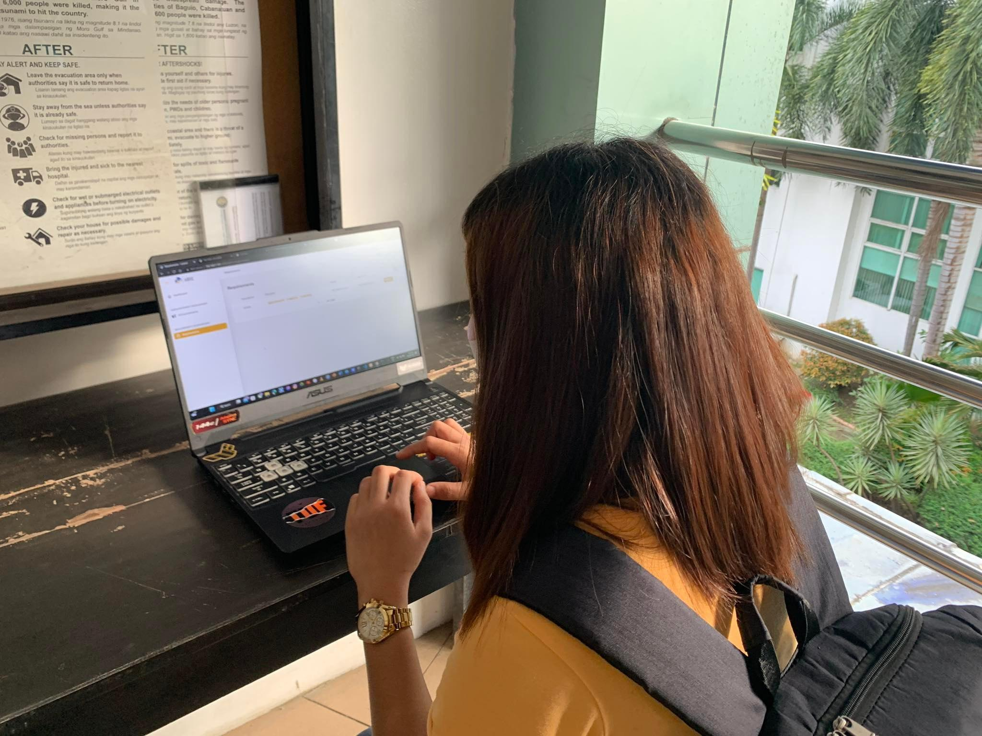

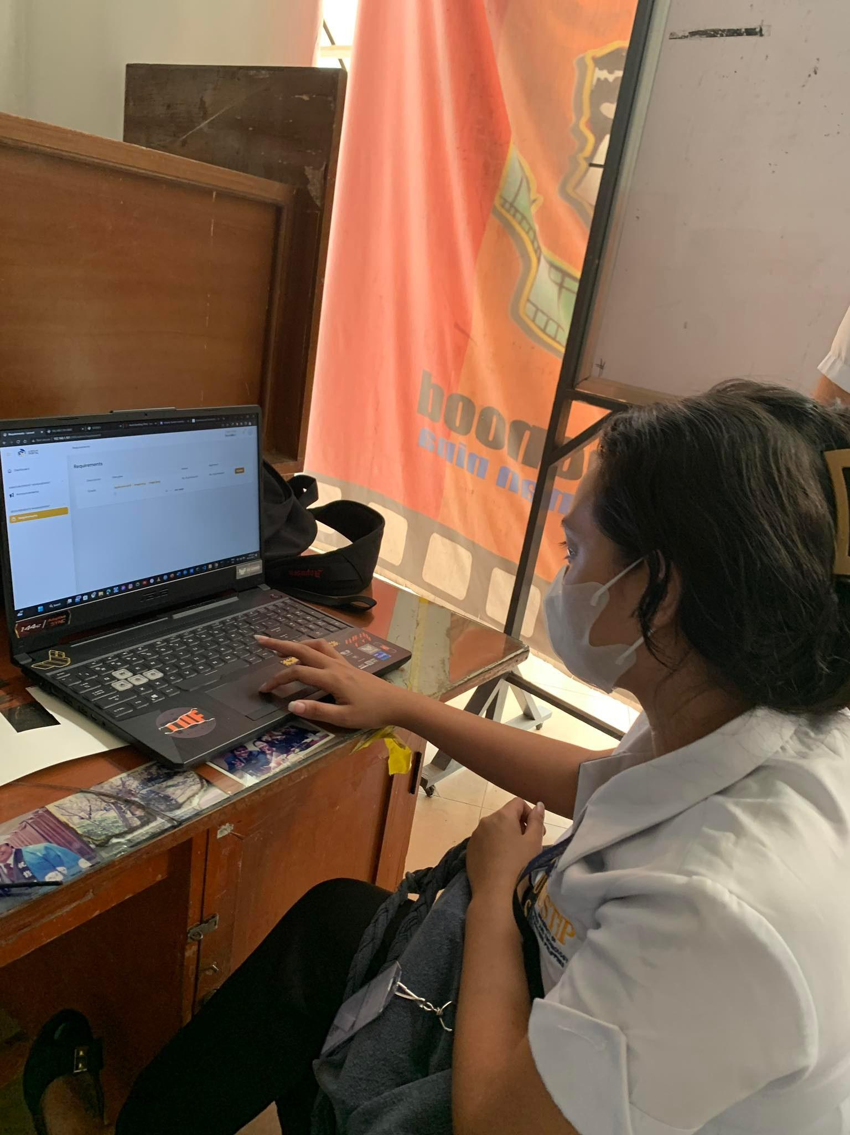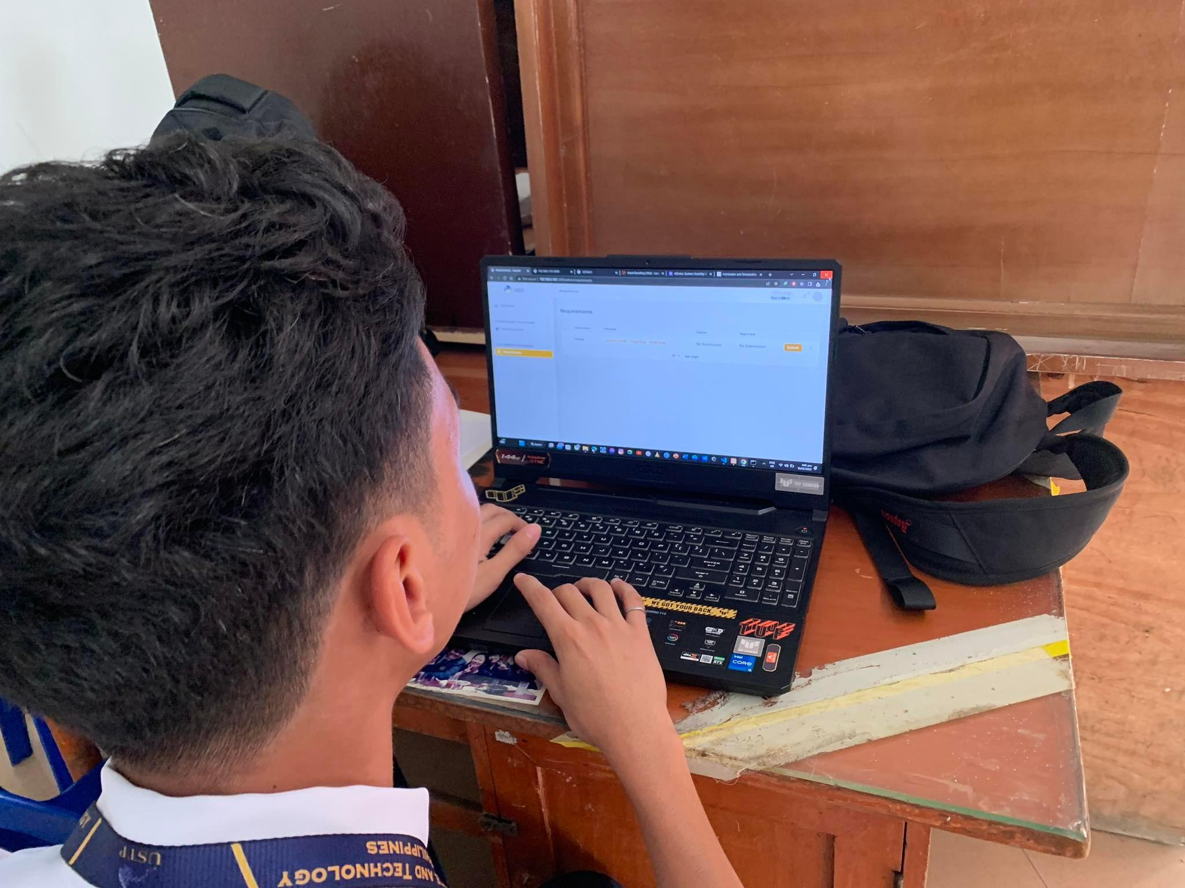

Scholars System Testing

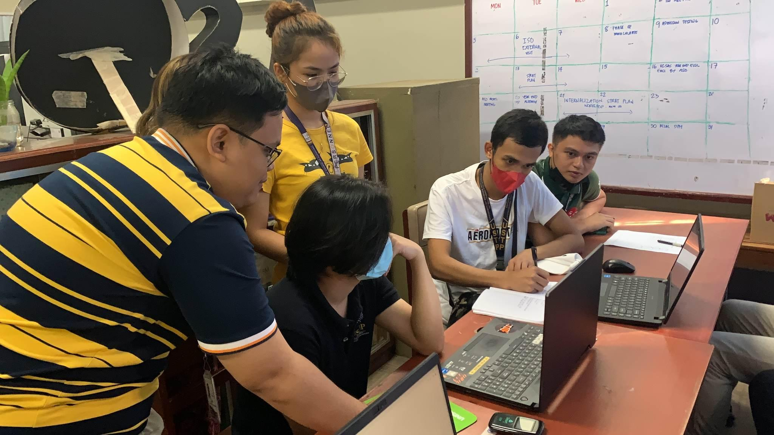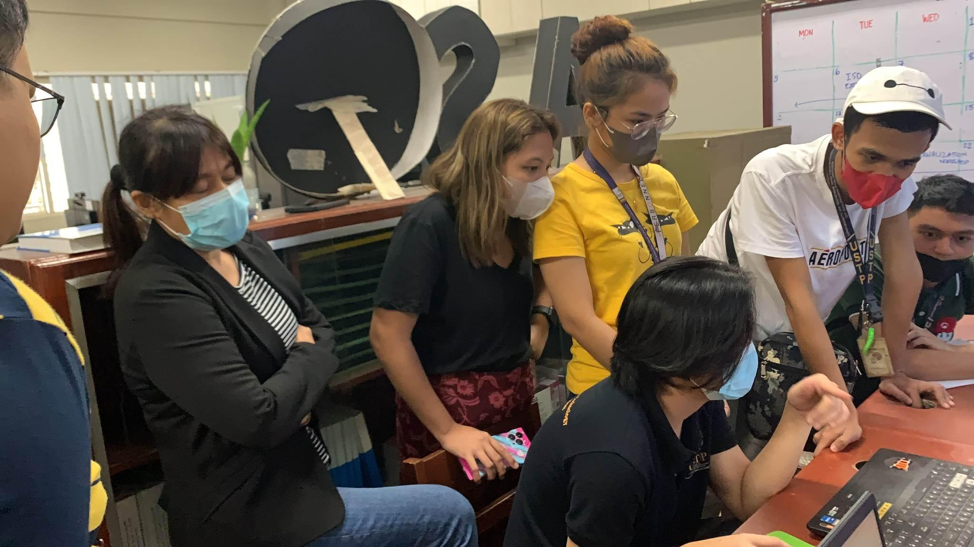

System testing with ASO.

APPENDIX F:

Curriculum Vitae

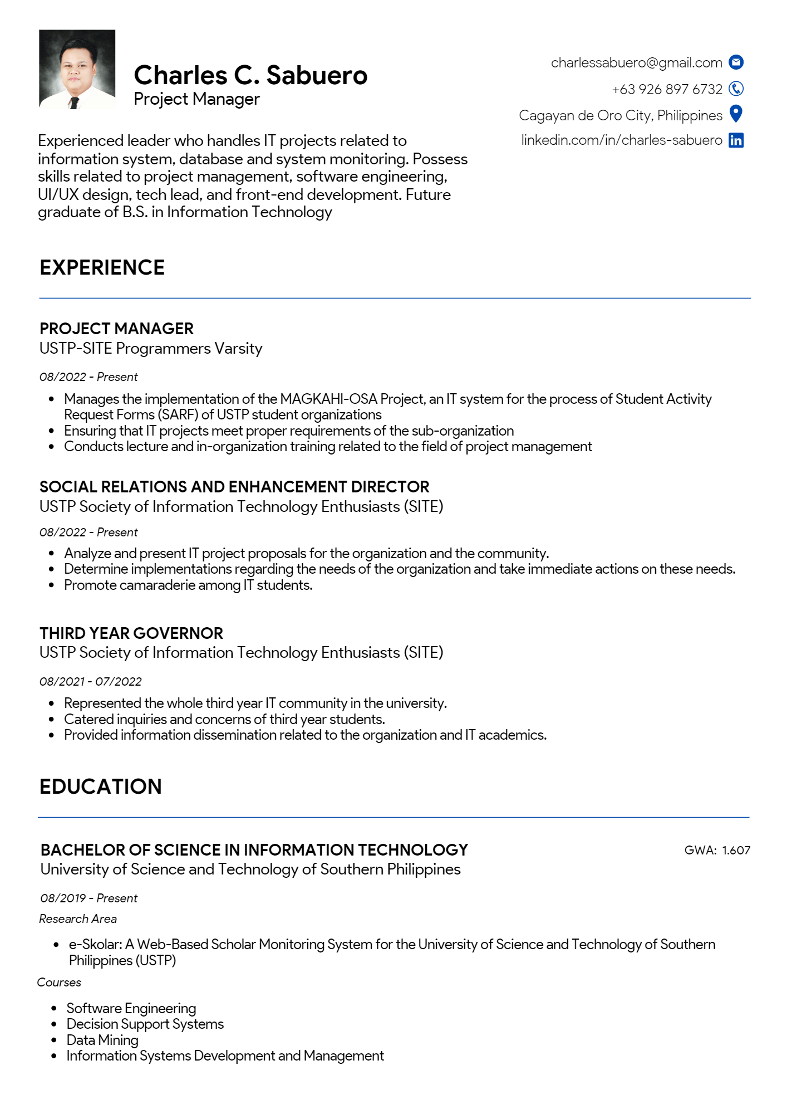





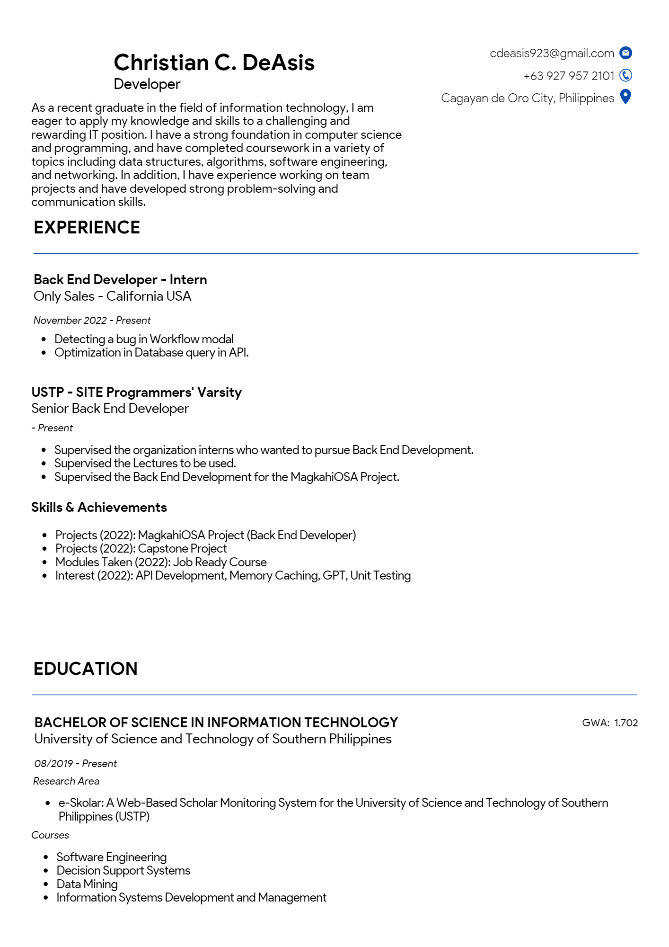

APPENDIX G:

Admission and Scholarships Office Organizational Chart as of April 11, 2023

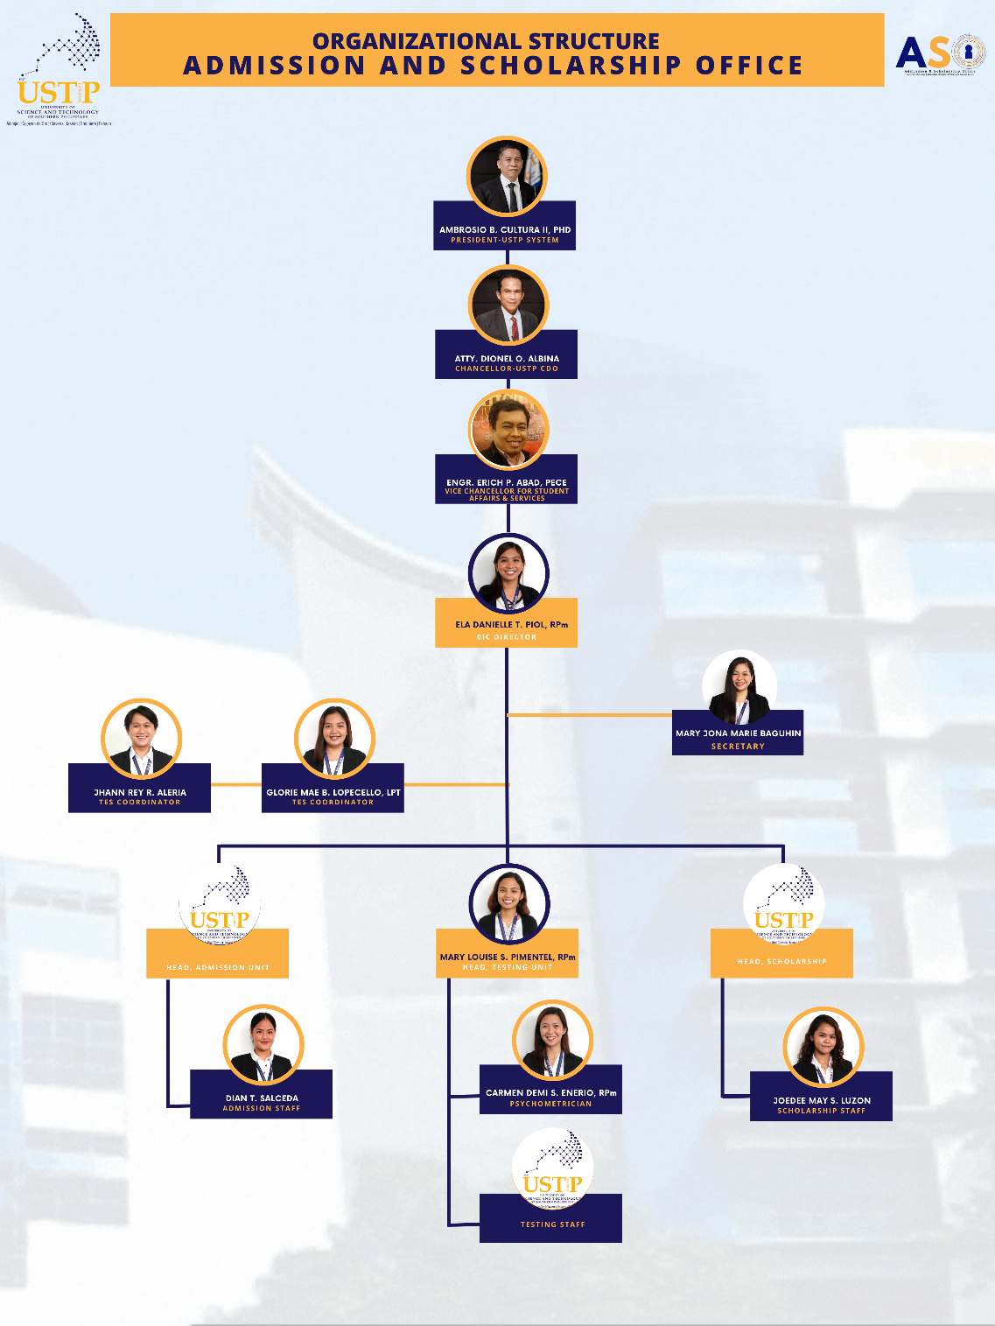

APPENDIX H:

Scholarship Manual



APPENDIX I

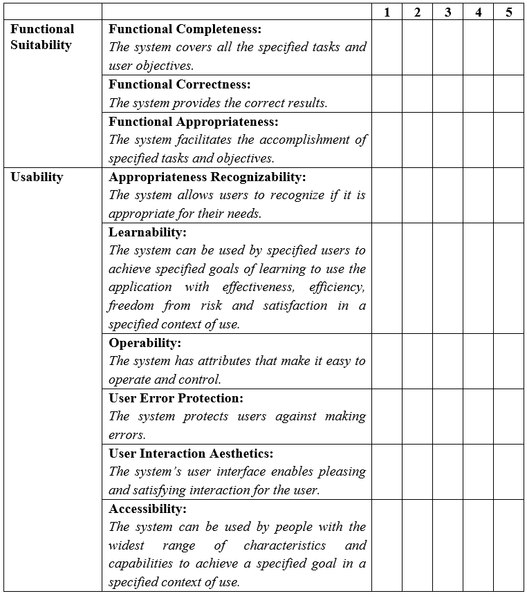Functional Suitability and Usability Test

APPENDIX J

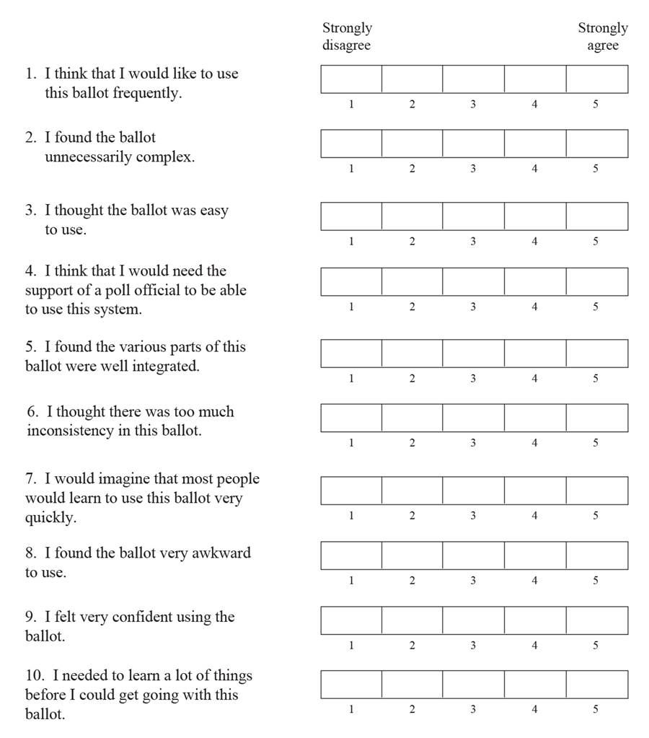System Usability Scale

APPENDIX K

Certificate of Acceptance